04. September 2019

I added some fotos because they will give an better idea of the surroundings and e.g. the mountains (to predict possible gusts).
Most probably you will find the fotos and tourist-stuff/walk-descriptions only here.

The following content was send as an update and addition to „The Marquesas Compendium“: http://svsoggypaws.com/files/#pacific to sherry@svsoggypaws.com
That is in my opinion the best place for these infos, despite some cruiser-reports there are outdated and the structure is not too easy to read.
I took the structure of the Compendium and marked my additions to the right chapter with color.
Thank you very much, Soggy Paws, to update and host "The Marquesas Compenium" (and many others !!! :-) to make cruisers life easier !!!

This document (content and fotos) is free for everyone to use under the GNU Free Documentation License.
- https://www.Taitonga.net/tipps_und_tricks_und_infos/2019-01-30_FP-Marquesas/0-0-The-Marquesas-Compendium-ADDITIONS-Taitonga2019.docx
- https://www.Taitonga.net/tipps_und_tricks_und_infos/2019-01-30_FP-Marquesas/0-0-The-Marquesas-Compendium-ADDITIONS-Taitonga2019.pdf
I will not update this document!

If you find something new, outdated or changed: Please add it to the Marquesas Compendium and depending on the content give noonsite.com an update as well (imho "Clearing into the country" is their turf => it makes no sense to have nearly redundant or outdated infos in several places on the net and have to check out which is the most current info).

Fair winds and have fun!
Christian
SY Taitonga

P.S. As allways: Take caution and commen sense! I take no liability for the infos!

SY Taitonga: Dagmar and Christian from Germany arrived in the Marquesas from Bahia de Caraquez, Ecuador at the end of November 2018, after nearly 34 days, with an Ovni395 (variable draft (add ca. 60cm to the depth soundings)). We have the rough idea of staying in French Polynesia until ca. 2020. https://www.taitonga.net

1 Introduction 3
1.1 EMERGENCY-CONTACTS 3
1.1.1 MRCC Tahiti - Search and Rescue 3
1.1.2 Marquesas Rescue-Stations 3
1.1.3 Emergency Telefonnumbers 3
1.1.4 SOS Médicins / Doctor Service 3
1.2 Suggested Routes 3
1.2.1 Kavenga's ... 3
1.2.2 When to travel to which part of French Polynesia (Pitufa) 3
1.3 Weather 4
1.3.1 Saildocs Weather-codes 4
1.3.2 Local weather sources (local Tahiti-time !) 5
1.3.3 Understanding the Weather Patterns 6
1.3.4 Experiences on the accuracy of the forecasts 6
1.3.5 Thunder and Lightning, Squalls, Waves and Swell, Currents, Rainy Season 6
1.4 Navigation: 7
1.5 Communication 7
1.5.1 Telephone 7
1.5.2 VHF-Channels 7
1.5.3 Internet 7
1.5.4 Radio Nets 8
1.6 Cruising Information Sources 9
1.6.1 Cruiser Reports 9
1.6.2 Yellowflagguides, tahiticruisersguide, Facebook 9
1.6.3 Supply-ships for the islands - timetables 9
1.6.4 Local information 9
1.7 Tsunamiwarnings free Mailinglist 9
1.8 Mailinglist for german citizens abroad 9
1.9 Ciguatera 9
1.10 Dengue, Zika etc 10
2 Inter Island Passage Reports 11
2.1 Tahuata to Hiva-Oa - Bordelais Channel: 11
2.2 Hiva-Oa to Tahuata - Bordelais Channel: 11
2.3 Interisland-Ferry: Hiva-Oa, Tahuata, Fatu-Hiva 11
2.4 Tahuata to Nuku-Hiva 12
2.5 Nuku-Hiva to Hiva-Oa 12
3 HIVA OA 13
3.1 Tahauku (Atuona) 13
3.2 Puamau (Hiva Oa NE Coast) 18
3.3 Hanamenu 18
4 FATU-HIVA 19
4.1 Hanavave, Baie V(i)erges 19
5 TAHUATA 21
5.1 Hanameneni Bay 21
5.2 Vaitehu 21
5.3 Hanatefau / Hapatoni 22
5.4 Hanamoenoa 26
5.5 Ivaiva Nui 27
6 Nuku-Hiva 29
6.1 South Coast 29
6.1.1 Taiohae (aka Rolly Bay) 29
6.1.2 Daniel´s Bay (Hakatea) (aka The Wall Bay) 34
6.2 North Coast 36
6.2.1 Anaho (aka Birdsong Bay, aka Squally Bay) 36
6.2.2 Hatiheu 38
6.2.3 Hakaheu/Pua 39
6.2.4 Bay Moutee 40
6.3 West Coast 40
6.3.1 Baie Marquisienne (Anse Uea) (aka Sound of Beachpebbles-bay) 40
6.3.2 Haahopu (Airportbay) 41
7 Ua Pou 43
7.1 Hakahau 43
7.2 Haakuti 43
7.3 Vaiehu 43
7.4 Hakaotu (aka calm. lonely, coloured rock bay) 44

Introduction

EMERGENCY-CONTACTS

MRCC Tahiti - Search and Rescue
SRR: French Polynesia
Telephone emergency: +689 40 54 16 16 (with a local phone just 16)
Telephone information: +689 40 54 16 15
Iridium: +881 641 425 630
INMARSAT C: 582-422 799 192
VHF 16 in the Societies
2182 kHz / 8291 kHz / 156,8 MHz
MMSI 005461000
contact@jrcc.pf, mrccpapeete@mail.pf
http://www.jrcc.pf
Location-17.5249996, -149.5566711
Notes: MRCC et ARCC en Polynésie française ont fusionné pour devenir le JRCC Tahiti, centre de coordination de sauvetage aéromaritime.
Le JRCC Tahiti est COSPAS-SARSAT SPOC.
Nos zones de responsabilité sont la SRR French polynesia et la FIR Tahiti.
(Source 10/2018: https://sarcontacts.info/)

Marquesas Rescue-Stations
Channel 16 - no permanent watch
Rescue stations on following islands:
Nuku-Hiva: 87 760 850 - Cedric Larson
Ua Huka: 87 234 703 - Thomas Athenol
Ua Pou: 87 700 899 - Patrice Gueret
Hiva-Oa: 87 708 115 - Marc Tarrats
Hiva-Oa has a semaphore for information and warnings VHF 16 and 09 / MHF 829, tel.: 40 927 660
facebook.com/FEPSM - volunteers "Federation d'Entraide Polynesienne de Sauvetage en Mer" (They work together with the MRCC Tahiti)
Do expect open aluminium boats with an outboard for shortrange - not suitable to tow yachts but to rescue crew.

Emergency Telefonnumbers
Paramedics 15
MRCC (Rescue at sea) 16
Police / Gendarmerie 17 or 112
Fire 18 or 112

SOS Médicins / Doctor Service
Telephone (+389) 4042 3456

Suggested Routes

Kavenga's ...
...

When to travel to which part of French Polynesia (Pitufa)
Depending on the seasons you might want to follow these ideas to see most of Polynesia:
http://www.pitufa.at/cruising-french-polynesia-the-best-times-to-visit-the-different-archipelagos/

Weather
Thank you Jacaranda, Pitufa and Soggy Paws for having parts of the following published:

Saildocs Weather-codes
Via query@saildocs.com it is possible to get infos with a low bandwith (e.g. SSB or Iridium or slow internet ...):
- Gribfiles (displayed on OpenCPN (we use zygrib.org as well for ECMWF-Model)
- Isobar-Charts and Synopsis as Text from NOAA- and Fidji-Meteo-Data
- Currents OSCAR from NOAA-Data
- Weathergram from Bob McDavitt in Newzealand, weekly
- ENSO-Discussion
- ...

SAILDOCS-Codes for email-requests [01/2019] (their help- and infosites sucks, but the hosting-service is good, IF you know the codes!)

email to query@saildocs.com
Subject: blank or your choice (e.g. what, where ...)
Body: See below
- send => once
- sub days=10 time=17:00 => subcribe the amount of days (days=0=infinite) automatically send at this time
- unsubscribe => delete the subscribtion

Saildoc-codes for cut and paste => below the explanations:
send fr.poly.en
send fr.poly
send fr.poly.short.en
send fr.poly.
send fr.poly.long.en
send fr.poly.
send gfs:7S,11S,141W,137W|1,1|0,6..168|=
WIND,GUST,WAVES,PRESS,=
APCP,TCDC,CAPE,HTSGW,WVPER,WVDIR,=
SWELL,SWPER,SWDIR
send spot:9.8S,139.0W|5,3|PRMSL,WIND,WAVES,RAIN,LFTX time=17:00
send pf.preiso36
send pf.preiso60
send PYFE11.TIF
send PYFI11.TIF
send PYFK11.TIF
send fleet.nadi
send FZPS40.PHFO
send nadi.sopac
send abpw10.pgtw
send RTOFS:6S,11S,141W,137W
send RTOFSx:6S,11S,141W,137W
send tsunami
send nz.wgrm
send https://meteo.pf/fr/point-hebdomadaire-saison-chaude
send http://www.cpc.ncep.noaa.gov/products/analysis_monitoring/enso_advisory/ensodisc.html

Explanations:
- fr.poly.en => 24h FP in Eng [ca.6kb; updated according to source below]
- fr.poly => 24h FP in French, the source for fr.poly.en; sometimes helpful, if the translation can not get the context, Thank Eric on Sarana, that he did a great job) [ca. 9kb; updated ca. 02:00 and 14:00 local Tahiti time]
- fr.poly.short.en => Short Range FP in Eng [see above]
- fr.poly.short => FP in French [see above]
- fr.poly.long.en => Long Range FP in Eng [see above]
- fr.poly.long => Long Range FP in French [see above]
- gfs:7S,11S,141W,137W => Full Marquesas Grib
|1,1 => Aera-Resolution (could be 0.5,0.5 or 2,2)
|0,6..168 => Timeperiod (could be 3,6,9,12, ...): Now, and then every 6 hours until 168h (max 16 days)
|= => "return", because the whole code does not fit into a single line and would fail
WIND,GUST,WAVES,PRESS,= => Wind in kn, Gusts in kn (imho mostly underestimated), Waves in m, Pressure in mb (Isobares)
APCP,TCDC,CAPE,=> Rain, Clouds, CAPE (indicator for e.g. lightning-possibility)
HTSGW,WVPER,WVDIR => sign. Wavehight, Waveperiod in sec, Wavedirection,
AIRTMP,SEATMP,WIND500,HGT500 => Airtemperature (2m), Seatemperature (surface),Windconditions in 500m above sealevel
SWELL,SWPER,SWDIR => Swellhight,-period,-direction; important for sailing e.g. from Tuamotus to Societies to avoid 2-3m swell on the nose from a southern system (the best free grib-viewer I know is zygrib.org and OpenCPN with the grib-plugin)) [Grib Marquesas 7 days, ca. 48kb, updated from 00:00h, ca. every 3 h]
- spot:9.8S,139.0W|5,3|PRMSL,WIND,WAVES,RAIN,LFTX time=17:00 => Spot Grib Forecast, spotcoordinates with Decimal-Minutes (/6*10)!, 5 days at 3 hour intervals [ca. 5KB; updated analog GFS-Source]
- pf.preiso36 => meteo.pf French Weather fax surface analysis 36 hour for the picture in French Polynesia, incl. fronts, ridges, convergence zones etc.) [ca. 19kb; updated ca. 02:00 and 14:00 local Tahiti time; Thank you Pitufa for making these available]
- pf.preiso60 => meteo.pf French Weather fax surface analysis 60 hour [as preiso36]
- PYFE11.TIF => Weather-/Isobares-map N and S-Pacific 24h (Big Picture, shows e.g. weather determined ridges better than pf.preiso..) [ca. 19kb, updated daily ]
- PYFI11.TIF => Weather-/Isobares-map N and S-Pacific 48h [see above]
- PYFK11.TIF => Weather-/Isobares-map N and S-Pacific 72h [see above]
- fleet.nadi => Weather-/Isobares-map in Fleet code from Meteo Fiji; Equator to 25S between 160E and 120W, you need a fleetcode reader (e.g. add-on in OpenCPN) [ca. 5kb, updated daily]
- FZPS40.PHFO => NOAA weather for the S-Pacific 0-25S, 120W-160E [ca. 5kb, updated daily, every 6h]
- nadi.sopac => Fidji weather for the S-Pacific 0-25S, 120W-160E [ca.4kb, updated daily]
- abpw10.pgtw => Significant Tropical Weather Advisory - W-Coast od S-America to 135E [ca.4kb, updated daily]
- RTOFS => Ocean current forecast from NOAA, and is currently available out to 192 hours [ca.4kb, updated once daily, generally available by 11z for 0-72hr forecast times and by 17z for 72-192hr forecasts]
- tsunami => Where, when an earthquake happend and if a tsunami is likely and what actions should be taken [ca. 8kb, updated occasionally, so best to subscribe]
- nz.wgrm => Metbobs weathergram only once a week, sunday [ca.4kb, updated ]
- Climate and Cyclone-discussion - 3-week-outlook during cyclon-season: https://meteo.pf/fr/point-hebdomadaire-saison-chaude [updated every Tuesday]
- ENSO - El Nino or La Nina or Neutral? from NOAA: http://www.cpc.ncep.noaa.gov/products/analysis_monitoring/enso_advisory/ensodisc.html
[ca.10kb, updated monthly]

To get general infos about Saildocs send a (blank) email to: info@saildocs.com (auto-responder)
To receive "Available Saildocs Grib Data", send the following one-line request to: query@saildocs.com
subscribe gribmodels days=0 => gives updates on the available models (seldom)
("0" means indefinitely).

Recommendation: Subscribe to the following services to recieve actual informations as soon as they are available: ca. 8KB each, 1-2 per week:
- Sub nz.wgrm days=0
- Sub tsunami days=0
- Sub gribmodels days=0

Local weather sources (local Tahiti-time !)
MRCC Papeete:
8803Mhz 07:30, 16:30, (special bulletins if Bft 7+, 12:30, 20:30)
VHF 13 (for the societies) 06:30, 12:00, 16:00, 20:00
VHF 26/27 Iles sous le vent

Radio polynesia 1 (Tahiti-Time, all french)
mon-fri: 05:10, 18:26; sat-sun: 06:10, 18:26
AM: 738Mhz
FM: polynesie.la1ere.fr/les-frequences-radio.html

www.meteo.pf

via phone: 44.27.08 ??

Understanding the Weather Patterns
Addition to 1.3.3 (imho worth to host a copy of this article as well on your site!)

Cyclones in FP (Great article from SV Panache):
https://currents.bluewatercruising.org/articles/panache-and-the-south-pacific-cyclone-season/

Experiences on the accuracy of the forecasts
SY TAITONGA, 25.01.2019
The islands create their own weather-systems, what you can get in the anchorages can be completely different to open sea (especially the gusts)!
The weather forecasts 1 or 2 days old are often a bit different to todays forecast, but the trend is visible. Because the covered area is quite big the forecast for Tuomotus could say SW-swell 3-4m, but that could maybe only affect the southern parts ...
GFS-gribs:
- Windspeed: +/- 5kn
- Winddirections:(+/- 15*)
- Gusts: +10-15kn +more
- Rain: seemed to be more of a guess

Isobarmaps: e.g. ridges were not shown in the isobarmaps from meteo.pf (saildocs: pf.preiso36 and pf.preiso60) but were shown in the NOAA-overview (saildocs: PYFE11.TIF, PYFI11.TIF, PYFK11.TIF).
The isobarmaps from meteo.pf are helpful to detect fronts and disturbed areas.

Textforecast meteo.pf
Helpful for a day-overview in addition to grib and isobarmaps (saildocs: fr.poly.en, fr.poly.short.en, fr.poly.long.en) => all 3 have different bits of useful info.

NEW 1.3.7

Thunder and Lightning, Squalls, Waves and Swell, Currents, Rainy Season
SY TAITONGA, 10.08.2019
In around 8 month (according to NOAA light El Nino turning neutral in July 2019) in the Marquesas we never heard a thunder nor saw lightnings!
Squalls were often passing, but only sometimes they were announced on the text-weatherforecast from meteo.pf (gusts); sometimes an "indicator" for us were the fronts and convergence zones in the preiso-pictures from meteo.pf.
Nearly every anchorage seems to have its own little weathersystem with local gusts or even no wind, while the clouds are telling another story.
We found some gusts near or between the islands aswell in sight of a mountain rather unpleasant. We experienced that the wind can go from 0 to 40+ in seconds (but mostly gusts are short); there are all sorts of local effects, (cape-, funnel, etc.),. e.g. in Anaho can be decent weather and in Daniels Bay you can have rainy squalls the same day,
The windwaves were nearly allways there (we never had flat calm conditions), but the problem is that they are often combined with uggly swell (mostly long) coming mainly from S to SW. This combination seems to find its way into every anchorage, which makes living sometimes quite uncomfortable (even some catamarans and 50m-superyachts complained in Taiohae:-).
Currents are mainly from the east, but confused near or between the islands and might be affected by the tides, aswell the underwater landscape - we were not able to figure out in advance what to expect.
Locals said rainy season is from June to October in the Marquesas, but added that the patterns have changed in the last years ...

Navigation:
Tidal range: ca. max. 1,2m (the differences in height regarding half-moon to new moon are small)
Best source we found: wxtide (imho not accurate sources: Navionics tides, Open-CPN-tides, Legacy-tides for Linux)
Sunrise/-set: ca. 04:30 dawn, 05:00 sunrise; 18:00 sunset, 18:30 dark (11/2018, local marquesan time zone = UTC-09:30; All other FP parts have UTC-10:00)

Communication

Telephone
Addition to 1.5.2
Country-Code: +389
The cellphone reception between the islands can go as far as 10nm+ (e.g. between Ua Pou / Nuku-Hiva, or leaving Oa Pou's westside toward Marquesas).
When a cruiseship has arrived the net seems to get an overload-breakdown.
It is possible to change the language to english (if you find someone who understands how:-)

- www.opt.pf Telekom and Post in French Polynesia
- www.annuaireopt.pf Yellow Pages for e.g. dentists and telefonnumbers etc. in French Polynesia

VHF-Channels
SAR: 06, 10, 11,
Port: 12
Ship-Ship: 08, 72, 77
(Many cruisers tend to listen to 72 and 16 and use 72 as a HAILING-channel amongst CRUISERS)

Internet
Addition to 1.5.3
Internet: At the end 2018 the islands are starting to get connected via a glasfiber-cable with the world, so speed should go up (someday, at least in the mayor places ... :-)
(04/2019: In Papeete we downloaded 1GB in 20 minutes, in Hiva-Oa 5MB in 20 minutes)

Internet options via Cellphone see:
www. tahiticruisersguide.com - Internet
www.vini.pf

VINI-SIM-cards can be purchased at the Post-Office (bring your passport!) for ca. 1000CFP (with some credit on it), as well recharge-scratch-cards with 500 or 1000 XPF, it might be possible to recharge via internet as well.
If you text "conso" to 7100 you get an SMS in return with your credit amount and left period to use it.
With a telefone-SIM you can do data as well. (e.g. using mobileVOIP on an androidphone gives you more calling minutes.

Configuration of an Android-Phone for Data:
1. Aller dans [Menu] > [Paramètres]
2. Cliquer sur [Sans fil et réseau] > [Réseaux Mobiles] > [Nom des points
d’accès]
3. Cliquer à nouveau sur le bouton du menu et sur [Nouvel APN] puis rentrer les
informations suivantes :
Nom : ne rien rentrer
APN : internet
Proxy : ne rien rentrer
Port : ne rien rentrer
Nom d’utilisateur : ne rien rentrer
Mot de passe : ne rien rentrer
Serveur : ne rien rentrer
Proxy : ne rien rentrer
Port : ne rien rentrer
MMC : 547
MNC : 20
Type d’authentification : Aucun(e)
Type d’APN : choisir default ou internet
N’oubliez pas de cliquer sur [menu] et [enregistrer]
4. Valider l’APN que vous venez de créer, en s’assurant que le point est lumineux.
5. Cliquer sur [retour] et cocher la case [données activées]
6. Aller dans [Menu] > [Paramètres] > [Réseaux Mobiles] > [Type de réseau
préféré] ou [Mode réseau préféré] ; Choisir le réseau souhaité : 2G, 3G ou 4G.
Vous pouvez désormais utiliser vos widgets et vos applications mobiles, aller sur
Facebook, voir des vidéos sur Youtube, gérer vos e-mails, jouer, découvrir et vous
informer.
Paramétrage manuel Internet Mobile – Mobiles Android
(Mars 2017)

Radio Nets

Radio Nets
Addition to 1.5.1
French operated Radio-Net: 13940khz USB 03:00 UTC

VHF-Net: In the Marquesas in 2018/2019 we found a working VHF-Net only in Taiohae on Channel 72, 08:00 local time (thank you Christian on SV Malakai).
VHF-Nets are operated for and by cruisers: If you do not hear a netcontroller, you are very welcome to do the net yourself! (Offer to distribute the "effort" :-) and fun, anyway!) It is fun and keeps your brain working and creates a cruiser-community! The only requirements for a netcontroller are: You know how to key a mike and speak (slowly). If there are questions, you do not have to have the knowledge to answer them by yourself => ask the fleet !!, dito with current weatherreports!

Possible structure (modify as you like)[ - WAIT after each section and count slowly to 9 to give time for answering]:
(An announcement of the net, 5 minutes before the time, allows people to hail someone before the net or to step out of their bed and prepare their coffee and cookies for listening :-)
Welcome to the "Location"-Net on VHF-Channel 72, which runs Monday to Saturday at 08:00, local time.
- Any Emergency or Priority Traffic, please come now. => WAIT
(Nothing heard, very good!) Today is the "day" of "month", "year". I am "soundso" on "soundso-vessel", with "soundso" on board.
- General Check-ins, please come now (so I know I am talking not only to myself:-).
Welcome to everybody! If you want to contribute in a section please state your boatname and wait until your acknowledged. => WAIT
- New Arrivals oder Departures, tell us where your coming from or going to, and who is on board, please come now. => WAIT
- Tides and weather, who has some infos, please come now. => WAIT
- Lost, found, crew needed, crew available, please come now. => WAIT
- Services, directions or help wanted or help offered, please come now. => WAIT
- Buy, sells or trades, please come now. => WAIT
- Announcements, events, please come now. => WAIT
- Open Forum, anything missed or jokes, trivia etc, please come now. => WAIT
Thank you for participating, the net is closed and the channel open again as the normal cruisers-hailing channel.

Cruising Information Sources

Cruiser Reports
Additions to 1.10.3
SY Tuvalu 2016 has good infos (in german:-) on the anchorages:
http://tuvalubarcelona.es/

Yellowflagguides, tahiticruisersguide, Facebook
Addition to 1.10.4?
- French Poly Group on Facebook
- www.yellowflagguides.com (Stopover Handbook in French Polynesia (e.g. 2018/2019), general infos + details on Marquesas, Tuamotus, Societies with tons of links)
The printed Version 2018/2019 can be obtained at Yacht-Services-Nuku-Hiva and the haul-out yard in Hiva-Oa Maintenance Marquises
- http://tahiticruisersguide.com/ Website made by cruisers with what is where available in Tahiti (and might be shipped to the Marquesas)

Supply-ships for the islands - timetables
For some harbours it might be good to know when they arrive and will use the harbour-basin for manoevers, e.g. in Hiva-Oa AND the next day the shops normally will have new stuff.
MV Aranui 5:
Timetable - leaving/arriving Tahiti: https://aranui.com/schedule-2019/
Itinerary - when on which island: https://aranui.com/itinerary-dashboard-2019/
MV Tapooro - Tel: 40 426 393

There are some cruiseships, which travel the islands also => e.g. up to 2000+ persons in Taiohae, Nuku-Hiva for some hours.

Local information
- Local school holydays: http://monvr.pf/wp-content/uploads/2019/07/Calendrier-2019-2020-mnl.pdf
- Local bank-holidays: https://publicholidays.asia/french-polynesia/2019-dates/
- www.peche.pf
- www.polynesie-francaise.pref.gouv.fr

Tsunamiwarnings free Mailinglist
from UNESCO:
http://itic.ioc-unesco.org/index.php?option=com_content&view=category&id=1437&Itemid=1437

Most villages seem to have an system to give audible warnings.

Mailinglist for german citizens abroad
Liste des Auswärtigen Amts für im Ausland lebenden Deutsche für Informationsmöglichkeiten bei Katastrophen, Unruhen, etc.: http://elefand.diplo.de

Ciguatera
Ciguatera-Reports are more than nasty and the poison will accumulate slowly in the body over time until the level will result in the symptoms (www.wikipedia.en/ciguatera).
The locals can not (logically) know which reef-fish or which bay is safe (today!), they might act like human testers until they get the symtoms.
=> A strategy to avoid Ciguatera is to eat only pelagic fish found in open waters (Tuna, Mahi-Mahi, Wahoo, etc.).

Dengue, Zika etc
Protect yourself anyway.
Worth to check the current news, e.g.
https://www.radionz.co.nz/international/pacific-news/386970/dengue-epidemic-declared-in-tahiti (04/2019)

Inter Island Passage Reports

Tahuata to Hiva-Oa - Bordelais Channel:
Addition to 2. x Tahuata to Hiva-Oa NEW (imho it would make sense as 2.4 and to move the others down)
Generall: https://en.wikipedia.org/wiki/Ha%27ava

SY TAITONGA, 10.12.2018
Tahuata to Hiva-Oa - Bordelais Channel:
The wind funnels here and the waves are steep.
We got the advice to cross early mornings even before 07:00 and hug the coast of Tahuata and then cross to Hiva-Oa.
Weather forecast was E12-14, seas moderate;
we got in lee of Tahuata less than 5kn northerly,
at 07:00 in the canal E10-15, 1m short waves, current 0,4kn setting E, 1h before high-tide.
We did traverse diagonally and would next time hug one of the shores first (a local motor yacht crossed directly to Hiva-Oa and then went very near the shore to round the cape)
We had a fishing line out and the medium octopus-lure was missing afterwards - the 0,8mm steel leader broke in the middle (some fish must have pliears-teeth ..).

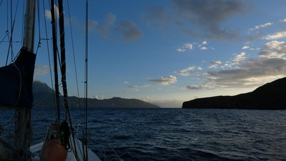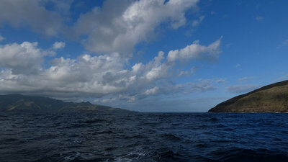
Bordelais-Channel W to E (left Hiva-Oa) E to W (left Tahuata)

Hiva-Oa to Tahuata - Bordelais Channel:
Addition to 2. x Hiva-Oa to Tahuata
SY TAITONGA, 16.12.2018
Hiva-Oa to Tahuata - Bordelais Channel:
We crossed diagonally around 09:30 and had a quick look in the possible anchorages on our way towards Hapatoni. We had a fishing line out and the small octopus-lure on 1mm monofil was missing afterwards.
French Weather forecast was E17/21kn, gusts 30, seas moderate; Grib (GFS): E 15-17, gusts 19.
We got: (maximum gusts in kn!):
3-5 all directions - Hiva-Oa, Tahuaka
8 ENE - Cap Teaehoa
10-15 E - in the channel
15-20 ESE - Pointe Matatehoke
20-25 E - Hanamoenoa (two boats anchored)
25 ESE - Ivaiva Iti
35 ESE - Vaitehu (one boat anchored)
45 ESE- Bay between Vaitehu and Hanatefau
20 W (!) - Hanatefau (two boats anchored)
At the beginning 1m short waves, in the middle of the channel long waves 1,5+m from E, (no current this time) in lee of Tahuata, no waves but little whitecaps with sometimes spray in the air from the gusts.

Interisland-Ferry: Hiva-Oa, Tahuata, Fatu-Hiva
"Te Ata O Hiva" - red motorboat for 40 pax. Does regular round trips Hiva-Oa => Tahuata => Fatu-Hiva => Tahuata => Hiva-Oa on Monday, Wednesday (not to Fatu Hiva), Friday; starts 06:00 returns 17:30, e.g. one-way 2500XPF to Tahuata, 4000 to Fatu-Hiva, carries freight as well (2018) Bruno 87 718 548, 40 927 307.

Tahuata to Nuku-Hiva
SY TAITONGA, 30.12.2018
We left Tahuata, Hanatefau around 16:00, gusts in mid 20ties 120* changing within 5 seconds- gusts normalized at the Bordelais-Channel; the wind did spread out and followed the W-coast of the islands. Miserable lumpy, bumpy complete dark night, squalls, rain, waves coming into the cockpit, slow despite halfwind (current?), wind around 20kn, arrived next morning in Taiohae

Nuku-Hiva to Hiva-Oa
SY TAITONGA, 25.01.2019
We left Nuku-Hiva, Daniels Bay at 09:00, and crossed the Bordelais-Channel shortly after sunset to arrive in Atuona around 08:30
weatherforecast: meteo.pf: valid until sat evening east 11/16KT, sea moderate.
Sunny friday, becoming cloudy end of day with of passages showers. S aturday, sky cloudy to very cloudy with of showers and related squalls sometimes stormy. wind from sector east moderated with of tips at/in 50 km/hr. no swell meaningful friday. arrival saturday a swell long from north-west D'1 meter.
GFS-Gribs showed 12-15kn 85* to 95*, going up towards the weekend.
What we got: wind 95-130* (mostly 110*), 5-17kn (mostly 14kn), short waves 1,5-2m 90* at the beginning, later 1m 60* with a low long northerly cross-swell, nasty current ca. 1kn+? setting west, we were not at all able to sail 130* to Hiva-Oa => Motor(-sailed). Half moon was good to see 2 squalls (ca. 25kn) with too little rain for the radar. Not many clouds until the morning. Wind, waves and current changed 10-15nm off Hiva-Oa, much more clouds with rain in lee of the islands.
Bordelais-Channel was ok with 15-22kn, gusts 30, directly on the nose, short waves 1-2,5m (higher closer to Atuona).

11-13nm from Ua Pou and 17nm from NH we were able to download weather/emails via our Vini cellphone :-)

HIVA OA

Tahauku (Atuona)
Addition to 3.1
SY TAITONGA, 10.12.2018 (we stayed 6 days and returned end of January for a haul-out)
HIVA OA - Tahauku (Atuona)
Some boats were anchored outside the breakwater (bumpy!).
Behind the breakwater, on the north-side, they have med-style moorings with stern-buoys mainly for the local motorboats, we saw there a big sailboat cruiser as well.
At the end of the bay you need at least one stern anchor, better 2. Please help new arrivals with setting their stern-anchors!
The Cargoships (e.g. Aranui) throw their anchor in the middle of the basin to park at a massive concrete-dock behind the breakwater on the South [propwash seemed to be ok ]. Their needed turning-space is marked by a big yellow buoy on the east and a pole as well as a sign on the shore on the west, also 2 poles in the middle of the bay, building a line. (Update 25.01: the poles are removed and dredging is still in progress; Update 15.04 Dredging seems to be finished).
It seems to be much colder here at night than elsewhere, maybe because of the freshwater-stream?
Semaphore Atuona was not answering at 08:00 and 09:00 on our arrival Monday (neither on 16 nor on VHF12); later we got contact.
Navigation lights: Green flash is working on the breakwater. The breakwater has some streetlights as well.
Holding: At our spot (09*48,1555'S; 139*01,8601'W [I would not dare to anchor nearer the shore]): Mud with stones and coral-debris - good for the Bügel-mainanchor facing towards the sea - only 3,5m depth, but we had 35m chain out to fit into our desired spot); ok for the 2 stern-anchors (in ca. 3m water depth, with ca. 30m rope): good for the Fortress, but the tripline caught itself in a coraldebris; the Danforth failed in the first setting. We buoyed all our anchors and prepared the anchors during anchoring in the harbour-basin (I would not dare to anchor in the crowd at night, but a quick stop in the harbour-basin until daylight would be ok for me).
11 boats in the anchorage, not much space, but ok. Wind came from all directions. Test all your anchors! One boat dragged. It took us 90minutes to get all anchors up and be ready for the sea again. (When southerly-swell is coming in, I do not want to be here!!!)
Update 15.04.2019: 18 boats in the designated anchor-area, 8 in the harbourbasin, 8 outside of the breakwater, rolly)
Water-visibility: ca. 1m in brown water with dark bottom, rain changed visibility to nearly 0.
Fouling: For only 6 days: Quite some fast growth, green stuff and barnacles.
Wind and weather: The weather forecast (outside) was NE-E 17-21kn, gusts 30, sea moderate E 1,5m.
What we got: everything (the wind direction can change 180deg in seconds), mostly N-NNW-NE offshore 5-15kn.
Swell/Rolly: Slight boat movements (1-2 out of 5 on the Dagmar-Scale) [In April it sometimes looked very uncomfortable from the boatyard)]
Local traffic: Outrigger-pirogues (up to 6 people) and small motorcrafts who sometimes are rushing through the boats anchored outside of the breakwater.
Dinghy landing: No dedicated dinghydock (it was removed in 01/2019). We parked at the concrete breakwater near the ramp, some use the ramp of the canoeclub or the rocks nearby.
Beach: Sand with rocks - this is the shortcut if you walk into town, which will cut off 10-15 minutes (normal walk-time: ca. 30min), but you have to cross a little stream - either you jump or get wet feet (or both :-) or balance over stones: Walk from the harbour on the road and take the dirt road down to the beach. Cross the little stream to the other side. There is a little steep path going directly left up the hill (if wet and slippery walk NW on even ground until you meet the paved road again). Nonos at the beach!
Trash-Disposal: Available behind the public shower (near the restaurant) as well near the gas station
Water: Available at the shower and near the ramp
Diesel/Gasoline: at the fuel station in the harbour, with jerry cans: diesel 142XPF/L, gasoline 140XPF/L in 2018, they accept the dutyfree-document, which you can get in Papeete; details see Grocery/Shopping (we were warned that they might have some water in the fuel)
Cooking-gas: Cylinders at the fuel station (Adapter for gravity-fills n.a.)
Flying objects: We got bitten a lot!: ashore and on the boat - mosquitos and nonos.
Internet: Wi-Fi at the restaurant + at the haul-out + in town
Manaspot 24h flat rate period starts at 10:00,
Vini-cell-coverage - Yes
SSB: sometimes ok(ish) for checking into the Polynesian-Magellan-Net (a lot of static here)
Iridium-Access: ok
Money: in town: Bank with ATM; Post (mon to fri: 07-12,12:30-15:00 (fri14:00)) with outside-ATM (max 25000CFP)
Gendarmerie (for Check-in): mon-sat: 07-12:00, 14-17:00, sun 9-12:00, 15-17:00,
tel.17 or 40 917 105
Police: tel. 40 927 045
Church service: 08:00
Services:
- Hiva-Oa-Yacht-Services - Wi-Fi, laundry, cars, check-in, duty-free-fuel-formalities, etc.; Past the haul out yard, up the hill at the semaphore is their trailer; hivaoayachtservices@gmail.com, Sandra speaks english: 87 232 247, VHF 12/16
- Hairdresser/Coiffeur: 40 927 230
- Vet, Pet-doctor: 87 701 415, juliettefoxbravo@hotmail.com
Car Rental (Calculate around 10000XPF for 1 day incl. insurance; they bring the car to the harbour; returns on Saturday and Sunday get a fuel charged by km, due to the closed gasstation [make shure the amount is plausible!])
- Car, e-bike, biycle rental: 87 311 106, 87 214 693
- Car rental 8953 7889 Kahau
- Car rental 8772 1717 Numa (we booked via Sandra HOYS a Suzuki Vitara 4x4 in good condition, good for 2 (very small for 4), no map but a spare tire and a jack:-)
Transport:
- Taxi Manavahai-Nui in Hiva-Oa, Clark Germaine, 87 274 154: Airport-Atuona 1500CFP p.p.; Tahauku (anchorage) – Atuona 300CFP p.p.
- Taxi Peterano Frida 87 707 202
- Taxi Touaitahuata Jeanne 87 771 963
- Air Tahiti office mon-fri tel. 40 917 110; you can book via a central hotline as well: 40 864 242 (press 2 for english!),www.airtahiti.pf
- Airport Paul Gaugin has a small restaurant and run down restrooms, they charged us for every kg overweight 8USD to Tahiti and might put the handluggage on the scale aswell; taxis should be prebooked, calculate for a taxiride to the airport ca. 15-20 min.
Hitchhiking to / from town usually worked for us; between 12:00 and 14:00 as well Sat afternoon (and maybe Sunday?) or after 17:30 not so easy...
Refrigeration: Valentin Oberlin 8778 8781
Tourist office: in the harbour 87 246 477 (no english); 8:00-12:00 (I only saw it open once, so you might want to call ...) in town 40 927 893 (08-11:30, 14-17:00). No english and not very helpful to us.
Laundry: Hiva-Oa-Yacht-Services, Sandra, 400XPF/kg (did a good job for us!) (according to touristinfo the only possibility in town)
Diving: www.marquisesdiving.com, marquisesdiving@gmail.com 87 241 995, 40 927 905, can pick you up for a dive in Tahuata aswell
Restaurants:
at the harbour:
- Heremoana - stationary roulotte-food-truck with seats under tents with Wi-Fi, big portions (one plate enough for 2 normal persons, e.g. tuna with Roquefort-sauce and fries for 1200XPF, Cola 1,5l 800XPF (Cola is already 500CFP in a store!)) - they have Wi-Fi!
(Service mostly slow, tables could be cleaner, food-quality differs: Once our fries arrived more cold than hot, they offered to heat them up in the microwave ... :-( Monday closed, Tuesday-Sunday 07:30 to 14:00, 18:00 to 21:00.
in town:
- Relais Moehau - regular menu, at night also wood fired pizza (pizza starting 1500, meat from 2000, desserts around 1000). 3 minutes before entering town on the right hand side views over the ocean. They offered to fetch us in their car after doing a reservation for 4. Opening hours: 06:30-08:30, 11:00-14:00, 18:00-21:00; tel.: 40 927 269; http://www.relaismoehau.pf; they are a small hotel as well and some speak english
- Make Make - Internet-Cafe (07:30-13:30),
- Sandwich place
- ...
BBQ: Mostly every Wednesday, 18:00-21:00, BBQ organized by the Semaphore (up the hill) - drinks for sale, entry 200xpf, you bring your own food for the grill.
Semaphore: This is a local lifesafeing-group, which is not supported by the government, they have a small open fast motorboat in the boatyard ready to be launched in an emergency. They listen to VHF 16, but normally only if a volunteer is available (not 24/7)! Walk 100m uphill from the breakwater towards the sea. Ask Sandra for details and maybe how to support them!
Grocery/Shopping:
Most opening-hours: 08:00 to 12:00 and 14:00 to 17:00 (+/- ca. 30 min!).
Red-price-tags mean that these articles are subsidized!
Stocks seem to be low 1 week before the next supply-ship ...; Vegetables are not easy to obtain.
Best selection 1-2 days after the supplyship arrived, but still new stuff unpacked after 4 days (some goodies disappeared after a couple of hours ...).
Better not to compare prices with Panama or Ecuador, they are compareable with Deli's in San Francisco or Paris - We were happy to be able to buy things ;-)

At the harbour:
- At the fuel-station/minimart (good selection !); they take credit cards; fresh baguettes in the early morning, you can order/reserve some for the next day (or get some in town). They have some fresh vegetables: cucumbers, tomatoes, lettuce... as well a lot of frozen stuff. Imho the best baguette in town. Fresh Tuna 1kg/900XPF. No alcohol. Prices seem to be better than in town. Nice service (speaks a bit english). Open 07:00 to 17:00, Saturdays until 12:00, sun closed; tel.: 40 927 185.
- Monday and Thursday Bernard 87 720 532 (speaks english) comes to the anchorage around 11:00 and sells veggies and fruits from his plantation, they offer selfmade bread, pizza and nice quiche as well; you can order before via telephone/SMS via his wife Anna: 87 280 789, anna.loridan@hotmail.fr
In town:
3 grocery stores with "nearly" everything - they all have different things.
- Magasin Gaubil - they have bread Sunday morning as well, they sell fresh fish in the cooler, tel. 40 927 557, 07:30-11:30, 14:00-17:00, sat 08:00 to 11:30, sun 09:00 to12:00.
- Boulangerie Shan - Bakery as well grocery towards end of town (turn right before getting to the Air Tahiti office 200m (mon to sat 05:00 to 12:00, sun 05:00 to 07:00)
- Magasin Naiki - 40 927 348 (the last store going out of town - we found here the best variety of fresh veggies and outdated cookies, quite some other outdated things as well); tel. 40 927 557, 07:30-12:00, 14:30-18:00, sat 07:30 to 12:00, sun 08:30 to 11:00.
- Food trucks could be in town in the morning, 1 near the post, 1 behind the bank (we found one opposite the hardware store with veggies, fruits and eggs (you might want to bring your own case)
- Fish could be sold in a cool storage on the righthandside after passing the Gendarmerie (we never saw it open)

- Pharmacie, near the post-office, tel. 4091 7165, Mo-Fr 08:15-12:00, 14:30-17:00, Thursday afternoon closed, Saturday 09:00-11:00
- Shop Gaugin - Hardware store (has even some metric stainless steel screws!), 07:00-11:30; 14:00-17:00 Sat 08:00-11:00; Tel. 40 917 080
B+B/Pension/Hotel:
- Pension Kanahau, Tania.Tania@life.fr, 87 701 626 (also on Facebook) (can organize tours, too) (e.g. 12000XPF for a double with breakfast)
- Relais Moehau (see under restaurant)
- There might be a cheaper option with a unit rented out by the commune => ask in the Mairie

Haul-Out/Boatstorage: Vincent 87 739 045 (speaks english), Maria 87 251 649. http://www.maintenancemarquises.com, In high demand during the cyclone-season - only one space was left in December 2018.
In business since 2016, currently they are building a big house + office (when finished the toilet and shower situation is hopefully better, now very basic in one shed only (shower and WC) - bring your own torch as well paper. They have Wi-Fi, electricity, water; no washing-machine. They can fill cockinggas tanks (500XPF/kg) and offer mechanical repairs etc. (sail repairs planned for mid 2019); storage of goodies or medicins in their fridge for your return is possible (If you leave cheese or goodies in their fridge make sure to pack it like a treasure and mark it very clearly, so it is not eaten by accident => Parmesan-cheese n.a. on this island!).
It is very sheltered located in what looks like an old quarry - not much breeze. The ground is mud, gravel and grass. A lot of insects running and flying around - you might want to cover everything which connects the boat with the ground with grease and cover the holes into the boat (e.g. with sponges) as well having poisontraps inside. Some cruisers sprayed boric acid around their boat. We found some insects nesting in little holes after our return.
Protect your electricity-cable from the rain with e.g. a plastic-bag to prevent the main-breaker to switch off.
The yard is locked with a combination-padlock at night (you might take the first line as a reference, not the middle one, while inserting the numbers).
The ramp for the hydraulic-trailer is at the beginning of the breakwater, just in the corner, they do the haul-out at high-water. The trailer-pads protected our through-hulls nicely. Only a 8m rope attached to our bow was required. The hydraulictrailer-driver did a good job! :-). The boat will stay horizontal during haul-out.
To maybe push the stern into the right direction we had another cruiser with a dinghy on stand by as well some long aft lines ready.
If you haul-out friday-noon, you most likely stay on the trailer until monday before they park you (quite close to neighbours). Make sure they park you leveled out (with the bow higher than the stern so the rain can drain out) and not too close to structures so you can work on the boat easily.
We returned after 2,5 month, the boat was in a good condition with no mold or mildew.
Day-light in mid-April from 05:30 (shortly before the SMA (adapted military service) is doing their Haka across the bay) to 18:00. The weather was mixed with rain, lots of clouds and sun (not enough sun to not use the yard-electricity). Mosquitos (all types) around, nearly no Nonos ... Visitors at night: a cat and some roaches (hopefully they stayed outside our cockpit-mosquitonet ...).
Welding/Metalwork: on the way to town, 200m after you go onto the street from the shortcut on the right is the Artisan-school Hiva-Oa CJA, who can do metal- and woodwork
Woodwork: see welding
Touriststuff:
- Roadtrip across the island to Historic Site in Puamau "Me'ae Iipona". Calculate for the trip ca. 100km and 2-2,5h drivingtime each way with some stops, Nice scenery! Directions: Take the road to the airport and then turn right at the roundabout and follow the "street"; mostly dirtroad with "some" potholes and the last bit is singletrack with interesting views down hill (We would not like to do the trip after or during heavy rain). The site itself is ok, but imho not great.
- The cementery in Atuona - very different grave-styles

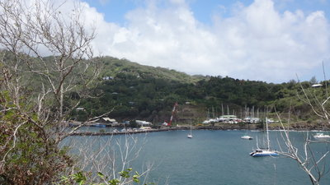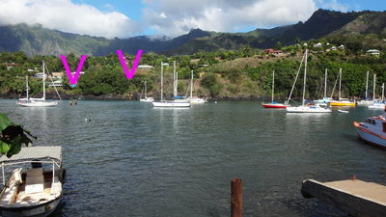
Outside the Breakwater + Haul-out-Storage Anchor behind the line of the rusty yellow pilars
(bumpy anchorage) to markers on W-shore as well yellow buoy (E)
(view ENE) (pilars gone in Jan 2019, but might come back?)
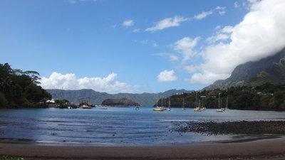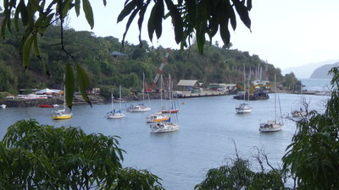
view from the beach left of the ferry-dock (roof) is the yellow buoy
(stay behind)
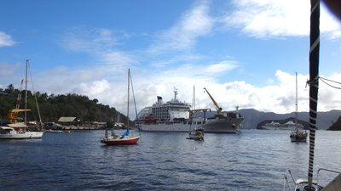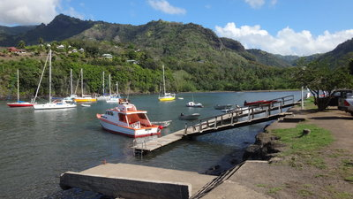
Aranui 5 in the harbour small dock leading to the floating dinghydock
(the background cruiseship stayed outside) (gone in Jan 2019 !, hoped to come back?!?)

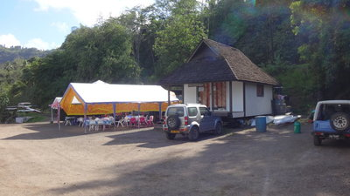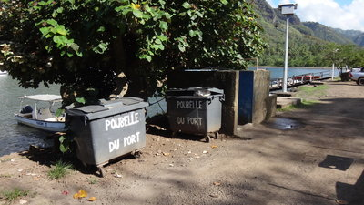
Restaurant and Tourist-info Trash and basic shower

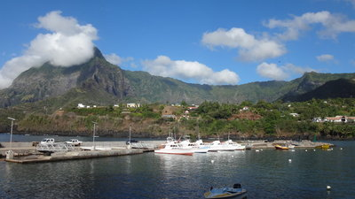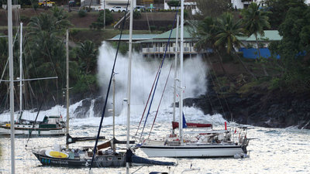
breakwater with med-style-moorings sometimes big southerly swell in the harbour
Foto by Jean-Baptiste Jacquet, SV Oneiros

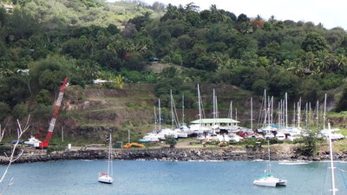
Storage MaintenanceMarquises (SE of the breakwater)

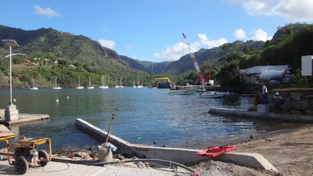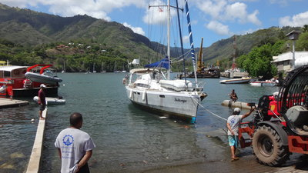
Haul-out-ramp inside the breakwater Approach onto the trailer is ok (calm conditions)
(at the left corner cruiser often park dinghys)
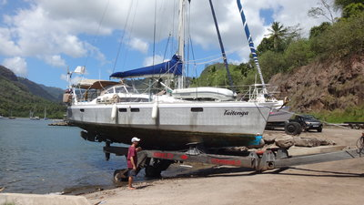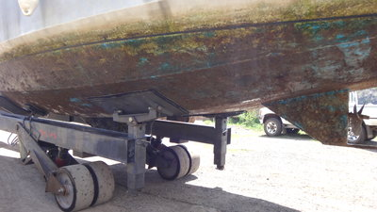
Haul-out-trailer, MaintenanceMarquises big Trailerpads

Puamau (Hiva Oa NE Coast)
[number should be upgraded to 3.3 (it is a location of its own)]
SY TAITONGA, 20.04.2018 (we visited by car)
A little remote hamlet - the scenic road from Atuona is in ok-ish condition (mostly dirtroad).
Public showers at the beach. Snack Therese, a restaurant, a church.
Historic Site "Me'ae Iipona" in Puamau - nice, but not great nor big, an english explanation chart at the entrance. Pay 300XPF p.p. at Snack Therese (we asked if we can harvest some fruits as well and were given instructions to a specific Pampelmousse-tree).
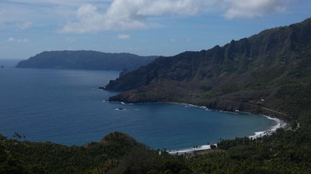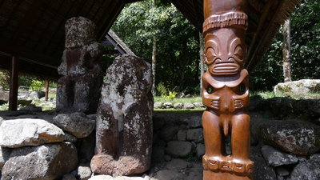
Puamau Bay (looking E) Me'ae Iipona - biggest stone tiki outside easterisland
(but not in good conditon (the wooden pilar tiki of the roof is new and more attractive:-)

Hanamenu
[Addition to 3.2.1)]
SY TAITONGA, 29.06.2019 (we visited only minutes)
On the way from Tahuata we had cellphonereception with data along the W-coast of Hiva Oa until we rounded the cape Kiukiu going east towards the bay (and downloaded the actual weatherforecast too late).
We tried to anchor here and decided against it; we returned after 10 minutes to Tahuata. The wind was with 045* (forecast 060* 12kn) to much from the north and it looked like the wind followed the coastline into the bay, with ca. 15kn blowing onshore, creating an too uncomfortable chopp for us. One cat stayed, one monohull stayed only 30 minutes and returned as well.
The water looked like stirred sand; the picture of the fishfinder looked like sand too.
It looks nice, indeed like an oasis surrounded by dry mountains - very different to other places, so we might try again.

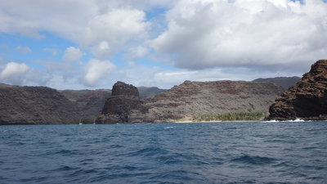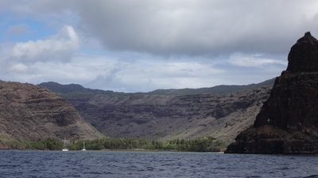
Entrance from the west with the west bay Hanamenu (east bay)

FATU-HIVA

Hanavave, Baie V(i)erges
Addition to 4.1
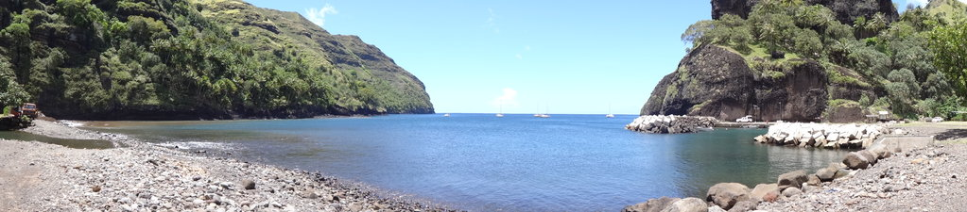
SY TAITONGA, 24.11.2018 (we stayed one week)
FATU-HIVA, Hanavave, Baie V(i)erges
Dramatic, stunning scenery, great light, nice sunset views over the open Pacific.
Anchored at high tide on 10m with 60m chain at position: 10 27.874 S; 138 40.048W
Navigation lights: No navigation aids, only a few street lights ashore, (I would not recommend arriving here without local knowledge at night)
Holding: Good at our spot (another vessel had difficulties with digging the anchor in while testing it full power in reverse (imho very good to test it very hard). 5 boats in the anchorage, nobody dragged.
Swell/Rolly: Slight boat movements (1-2 out of 5 on the Dagmar-Scale)
Water visibility: ca. 5-8m in clear water with dark bottom, visibility changes with the rains.
Wind and weather: The weather forecast (outside) was E 12-14kn.
What we got: This bay has its own weather. Easterly winds funnels from the mountains out of the bay, sometimes ground wind at night 18-22kn, gusts 30kn; daytime seems to be calmer (sometimes nearly no wind), still with vicious gusts; sun, clouds, rain can change within 15 minutes; The top of the mountains are normally covered in clouds.
After leaving Fatu-Hiva we experienced within 2nm of the islands alternating winds between 06-26kn with wind shift up to 70deg (and ugly rain).
Local traffic: Little open aluminium Pangas day and night. Wake no problem. They are hard to spot in 1m swells, but give a good radar-echo (a bigger cabin cruiser had a much weaker signal!); Nearly every day a bigger boat arrived for delivering or collecting people, staying outside of the harbour for ca. 30 min.
Dinghy landing: In the protected dinghy-harbour on the north side of the beach, we used a stern anchor, there is a boat ramp
Beach: Big black rocks, not really a beach, kids use the boat ramp for swimming.
Trash-Disposal: Not available => Hiva-Oa
Water: A faucet at the harbour can be used for free, a hose (with a filter) can be connected, small particles in the water
Flying objects on the boat: Many, many flies and sometimes a lonely big yellow wasp like creature, no mosquitos (they will find you ashore)
Internet: „Hotspot Vini“, with 1-2/4 bars on the boat, but we were not able to log-in, neither to buy a SIM-card, neither to pay via credit card for the Manaspot hotspot ...
Post: 08:00 to ca.! 11:00, weekdays, supposed to have the „fastest“ Internet and may sell Vini-SIM-Cards (besides the Town-Office – straight from the jetty, cross the bridge, turn left (7min walk)).
Iridium-Access: Bad, it takes longer and the connection broke down often - the bay is surrounded by 3 steep mountainsides
SSB: Good for checking into the Polynesian-Magellan-Net
Church service: Sunday 08:00
Services: „Taua (Christian)“ offered Taxi-Service with his launch to Omau, restaurant service and a carved Stone-Tiki (turn right after the school, first (yellow) house on the left);
„Rosa“ (lovely elderly lady) offers dining for 2000 XPF/p.p. (she is willing to take Euros, but no USD) (go towards the post, first house right after the bridge);
Laundry: Most likely possible in a private household
Money: Exchange here is not possible => we were told in the magasin in Omua ...
Bakery/Baguettes: Non available! => we were told in Omua ...
Sweet Coconut bread available after church service near the church (I repaired a washing machine and was given a self-made bread as a thank you :-)
Shopping: Little magasin, but has quite a lot to buy but not everything in stock. Tomatoes seem to be imported and only sometimes available – only garlic and onions were in stock (the supply ship was awaited in 5 days). Prices imho are not unreasonable (if you e.g. compare an organic egg sold in Frankfurt, NY or Seattle with one here => Fatu Hiva it is more or less even); 07:45-11:00, 14:30-16:30 mon-fri, 08:00-13:00 sat, 09:00 sun
Barter: Nobody wanted money – it seems they partly depend on goods brought in by cruisers. Some people offered fruits for exchange (they seem not to grow vegetables), they asked us for e.g. fishing-line, very big twin hooks for tuna, lures, rope, batteries, beer, Coca-Cola, perfume and again perfume, leggings, shoes and again shoes, t-shirts/blouses, sunglasses, …
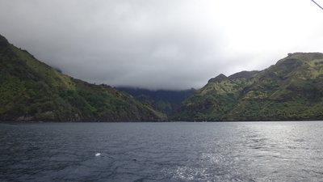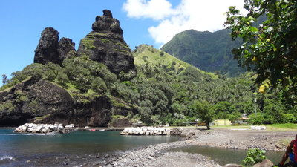
Approach little harbour (View north)

TAHUATA

Hanameneni Bay
SY TAITONGA, 25.05.2019
We anchored in 7m at 09*53,60S, 139*04,92 in sand with good holding, without stones, but look out for stones.
Two beaches with some moorings for local boats in front of each beach. We landed our dinghy in the middle part of the west-beach; nice with some weekend-huts, NoNos as well Mosquitos.

Vaitehu
Addition to 5.3
SY TAITONGA, 22.12.2018 (we visited by dinghy only one afternoon)
We were anchored in Hanatefau and dinghyed here, which took about 20 wet minutes (softbottom dinghy with 8hp).
The weather forecast (outside) was: Grib: E 15kn, gusts 18kn; Meteo France E 11/16kn, gusts 25kn.
We got: The wind both (!) ways was directly on the nose, gusts 20-30kn (the general wind/clouds changed von ENE at noon to E later; quite gusty (offshore) in the big bay [Friends reported: good holding, gusts going offshore up to 50+kn].
Nice church to visit. The Aranui arrived around 14:00 and some carvers displayed their goods. The shop partly stocked up, but it seems much better to shop the day after they had time to fill up the shelves, better selection is in Atuona.
Holding: We returned 03.07.2019. 4 other boats in the anchorage. The swell/roll was better than in Hanamoenoa. The ground looked ok for us, but we saw a strange echo in the fishfinder and ignored it. We anchored on 10m with 40m chain at 09* 56.25`S; 139*06.69'. Despite light onshore winds we drove the hook in towards the sea, it took 10 m ratteling until the hook was holding - there was something strange on the ground - we were happy to get it up again and went to Hanatefau (The swell/roll-conditions were better in Hanatefau than in Hanamoenoa, but Vaitehu was the calmest that day).
Dinghy landing:
Jetty - at the N-side of the shore with concrete steps (+ a ladder at the E-corner), used for loading passengers and freight; completely exposed; we had a bit less than 1m swell coming into the bay and where dropped of by another cruiser - the dinghy took some damage.
Rivermouth - ca. 15m wide; sand with some stones before a low bridge; there was no water in the stream. Good timing for the waves and maybe dinghywheels could be helpful for landing in a swell. At low tide many stones => it might be a good idea to land not before half tide on a rising tide.
This is the bathing place and playground for the local kids, so please take care! (You might find some sandy little footmarks in your dinghy after you return :-) There is a rough ramp for the local fishing-pangas going into the rivermouth on the N-part.
Beach: no, big black rocks, except the rivermouth
Baguettes: in the Magasin (were sold out at 13:00:-(they only bake monday, wednesday and saturday; you might want to reserve your baguette in advance)
Shopping: Raihauti Magasin, tel. 40 929 019, has a little of nearly everything, we found cucumbers, potatoes, carrots (old), (onions got just delivered outside),..
On the street towards south to Hapatoni, ca. 200m from the shore uphill, there is Manu's plant-nursery: possibility maybe for vegetables, bananas, ginger, ...
Teiki is the islands beekeeper and sells local honey.
Post: We were able to buy SIM-cards as well rechargecards.
Infirmery: Last house at the southern end of the seaside-road (maybe "only" a nurse and visiting doctors?)
Cellphonereception: good reception with data, the cellphonetower is on the northern hill.

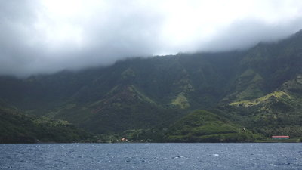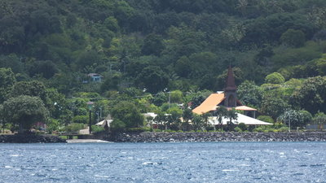
Bay The rivermouth is left of the church

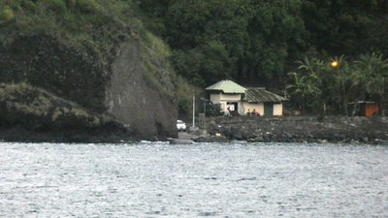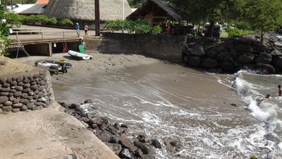
Concrete Landing is left (N) of the bay Rivermouth (kids-playground), rocks begin where the surf is (right side seems a bit better)
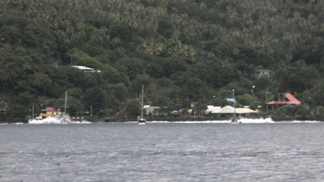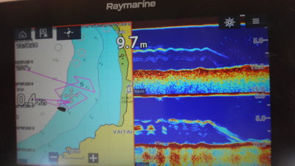
sometimes ugly swell breaking ashore weird echo in the fishfinder 09* 56.25`S; 139*06.69'

Hanatefau / Hapatoni
Addition to 5.3. (Maybe splitting them in 5.3.1 and 5.3.2 would make sense?)
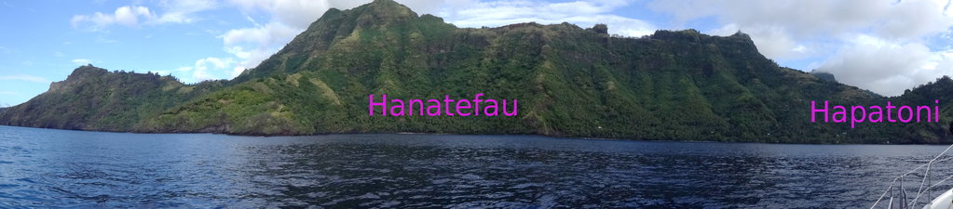
SY TAITONGA, 03.12.2018 (we stayed a week and xmas)
TAHUATA – Hanatefau, Stunning steep high mountain, lush green, great scenery.
A coconut plantation, with a single hut, on shore, nice sunset views over the open Pacific (Hapatoni-Village is south in the „next“ bay (ca. 0,7nm).
Sometimes dolphins.
Navigation lights: None (but see Hapatoni), no lights ashore
Holding: Good at our spot in sand. 2-5 other boats in the anchorage. Anchored on 12.5m (high tide) with 60m chain on sand at position: 09*57,73S; 139*07,14W. Closer to shore as well more south are some rocks and boulders! The anchoring plateau drops very fast after 15m depth!
We arrived with no wind and were not sure in which direction to dig in the anchor => we decided to get protection from gusts down the mountains (wrong!!!). There is a current in the bay.
Swell/Rolly: Slight boat movements (1 to 2 out of 5 on the Dagmar-Scale), in June we had a day of high but long swells from the south, dito a couple of days in July.
Water visibility: ca. 12m+ in clear water (we saw our anchor from the dinghy).
Fouling: Nearly nothing, only a bit green stuff.
Wind and weather: The weather forecast (outside) - Grib: 12-19kn ENE; Meteo France 19/21kn, gusts 30kn. The top of the mountains were slightly covered with clouds which the easterly pushed to the west.
What we got: Winds onshore ! Back-circulating eddies from the normal easterlies, from NW, W and SW with ugly gusts up to 30+kn! Gusts mostly around 30 seconds; „only“ wind – no wind waves! It seems nearly nothing of the easterlies comes down the mountain. Mostly our bow pointed towards the sea! Some short rain showers.
We returned in May 2019 for 5 weeks: The strongest gusts (ca. 30+kn with around 18-20kn easterly weatherforecast) were still mostly onshore, but northly as well, southerly stronger wind as well, once even directly down the mountain (during easterly gusts the boats in the northern Hapatoni anchorage (up to 4-5) had complettely different wind). Usually it was 5-10 kn from all directions (less than in December). Up to 12 boats in Hanatefau - some faced stern to stern due to the current and weird winds, some were too near each other, but still 50cm apart :-).
The peak of the mountain is rarely without clouds => not much solar energy.
Sunrise at 06:00, sunset 17:30 (around 30 minutes dawn/dusk).
Much rain in June and beginning of July.
Wildlife: In December two pods of dolphins. In May nearly every morning dolphins (up to ca. 50-60) with some little ones, who were trained spinning in the air and splashing around by their parents, sometimes rays; beginning of June the number of dolphins went down, mid June rarely dolphins, end of June ca. 20 returned for some days (sometimes only a couple meters from the boat), mid July still dolphins in the bay, only us and up to 3 boats in the anchorage [it looks like the Marquesas-High-Season comes to an end]).
Local traffic: see Hapatoni
Dinghy landing: bare rocks - landing imho not possible, some anchored their dinghy in calm conditions and swam ashore
Beach: no, big black rocks
Flying objects on the boat: only a very few, some flies, one mosquito
Cellphonereception: Sometimes, depending on the anchorspot/wind! Data-reception (email/whatsapp) was not possible for us
WiFi-Internet: None
Iridium-Access: not good, one side is blocked by the steep mountains
SSB: Good enough (mostly) for checking into the Polynesian-Magellan-Net
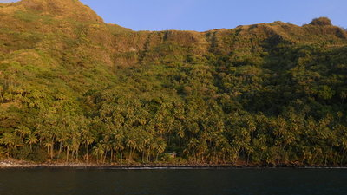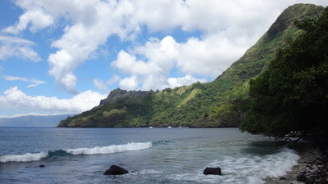
Hanatefau shore view from Hapatoni

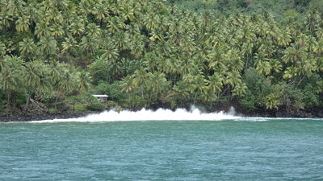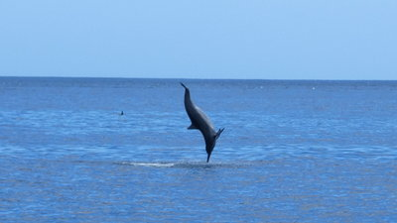
Sometimes southerly big swells Dolphin-training-center => one of the Pro Group

TAHUATA – Hapatoni (we visited via Dinghy) [our favorit !!!]
We anchored in Hanatefau (0,7nm north) and dinghyed here. Ca. 100-150 inhabitants. Nice little village with a lot of harmony. Person to address for infos in the hamlet is Tehina in the blue house (very nice lady, speaks english).
Navigation lights: a green pole with a green light on top (we saw it working only once...) on the breakwater at the dinghy-harbour in Hapatoni, 3 streetlights in the harbour, only a very few lights ashore, streetlights in the village are installed but not powered.
The Bay of Hapatoni and Hanatefau is separated by a rock ridge, on top of it (maybe at 80m height) is a cross and a shrine, which is illuminated at night and might be used as an “idea”.
Holding: ? (reported by locals to be dead coral in front of the harbour), in the northern part (away from the harbour) up to 5 boats where anchored (looking down from the cross it looks like there are sandpatches).
Water visibility: ca. 3m+, dark bottom near the harbour
Local traffic: Not much traffic from/towards Vaitehu, one Wednesday night the Taporo anchored in front of Hapatoni (arrived at night, left before sunrise). The Aranui can send one of its tenders from Vaitehu. A "regular" speedboat visits and operates as a ferry to Hiva-Oa.
Dinghy landing: Easy, in the protected dinghy-harbour. There is a boat-ramp on the eastside which even bigger local boats use and this is the playground for the kids! We used a stern-anchor and stayed near the western corner, so visiting ferryboats had the chance to go to the quay as well. You want to have your dinghy in the far western corner during the time the big cargoships do the loading with their massive tenders, which will create wash towards the boat-ramp; they use an excavator on the wharf as a crane for loading (copra, fuel, noni etc.) - beware of the turning circle.
Beach: Big black rocks and some sand
Trash-Disposal: Vaitehu or Hiva-Oa (if you might find a trashcan you may not want to use it, because then they have to separate the trash and take it to Vaitehu)
Water: n.a.
Cellphonereception: Yes
WiFi-Internet: No open hotspot, you might want to ask a local
Church service: 08:00 Sundays in marquesan language (incredible good singers, awesome !!! They take the ceremony serious, but the kids can behave like kids. You might want to dress "appropriate" (no spaghetti-top or hot-pants, cargoshorts for men and flipp-flopps are ok …).
Weekdays at 17:00 they have shorter services.
Services: n.a.
Money: n.a.
Baguettes: n.a.
Shopping: No magasin;
Carvers (specialty bonecarvings) - ask around, https://hapatonisculptures.wordpress.com/ ;
Fish: ask Tea (Robert) (40 929 096), first house coming from the harbour going straight, you can order for a specific date and the night before he will try to catch Sushi for you.
Barter: We were not activly approached like in Fatu-Hiva. If you need something you have to ask.
Dancing: If occasionally a little cruiseship arrives, like the "Orion" from National Geographic, they do great performances!
Things to see: The street along the shore aswell the ceremony-plateaus between the maree and the church are ancient remains (bigger than in Hiva-Oa, Puamau, without Tikis, but with a petroglyph).
There are petroglyphs walking towards Vaitehu after the bay of Hanatefau. After ca. 40m after the beginning of the concrete street which goes up the mountain, there is a little sign in ca. 1,5-2m hight on the right (easy to miss), where you go ca. 50m into the woods (bugspray), slippery when wet. Walking from the hamlet takes around 40 min, each way (for kids and rusty crusiers:-) [see photos as indicators].
Walking: There is a dog who chewed on some cruisers in the last house towards Vaitehu (near the cross). If you dare to walk from the northern Hapatoni-anchorage through private land you might want to know that => avoid. Staying on the road towards Vaitehu should be ok.
Fruits along the way are private property => ask.
A walk between Vaitehu and Hapatoni is very scenic and is reported to take ca. 2,5 hours oneway (we hitchhiked :-). On the way there is a small sign to some petroglyps, after you passed the bay of Hanatefau on the first concrete part of the road, after ca. 80m on the right hand side.
A walk between Hapatoni and Hanateio on the south-east-coast is reported to take ca. 3-4 hours oneway and to have great views (we opted out :-)
School: They have a one-classroom-school with ca. a dozen kids in different levels. If you want to share knowledge about your homecountry and enrich their horizon (geography, social live, work, school, fotos etc.) you could ask Tehina the teacher, if it fits into her schedule (first house going ashore).

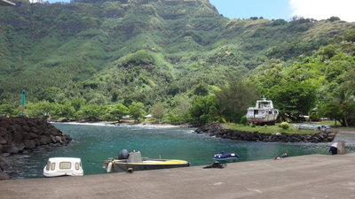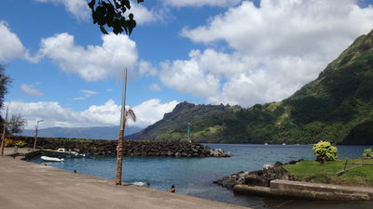
Harbourview towards the village view towards Hanatefau

Walking to the Petroglyphs
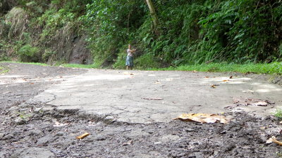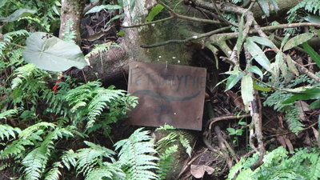
first concrete part uphill - Dagmar shows the way to the sign
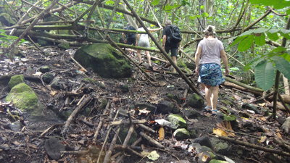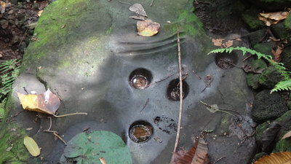
slippery! Follow the chopped branches Inkbarrels for tattooing and sharpening marks
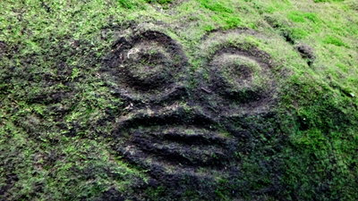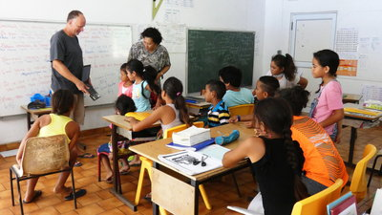
sacred site At school in Hapatoni (one classroom for all)

Hanamoenoa

Addition to 5.1

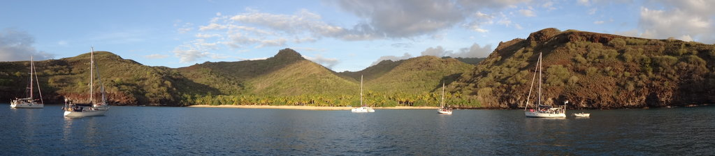

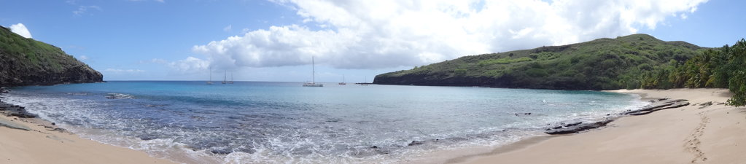

SY TAITONGA, 30.06.2019 (we stayed a couple of days)

Nice scenery with a hilly background, sand beach with palmtrees and some huts.
Navigation lights: None, no lights ashore
Holding: Good at our spot in sand. 11 other boats in the anchorage. The anchoring plateau looked ok for us at less then 12m. The anchorground has some rocks, depending where you anchor. There is a reef/stone-hump near the beach. Close to the beach in the southern corner it looks not perfect for anchoring. Not much current in the bay.
We anchored on 9.5m with 40m chain on sand at position: 09* 54.49`S; 139*06.31'
Behind us and more south to shore were some rocks.
Swell/Rolly: boat movements (2-3 out of 5 on the Dagmar-Scale), we had a southerly long swell from the south announced, but the swell in the bay came mostly out of the north, so out of th channel. The swell was reflected and confused by the walls.
There is a blow hole on the northern side of the bay.
Water visibility: ca. 10m+ in clear water (we saw our anchor from the dinghy and rocks under the hull).
Wind and weather:
The weather forecast (outside) - Grib: 8-12kn ENE. The top of the hills were slightly covered with clouds which the easterly pushed to the west and which were dissolved through the sun.
What we got: Winds offshore 5-10kn.
Wildlife: Small Mantas said hello - it seems that they do not go deep into the bay.
Local traffic: not much bypassing
Dinghy landing: on the beach more to the north, south is rocky, swell can be challengeing.
Beach: lovely, but please respect the privacy of the owner => the big effort to install barbwire towards the beach might reflect bad cruiser behaviour. Going inland might be better on the southern side.
Flying objects on the boat: only a very few, our geckos had to be feed with additional food
Cellphonereception: little reception, sometimes! Whatsapp worked, email not (not even in the mast).
WiFi-Internet: None
Iridium-Access: ok
SSB: Good enough (mostly) for checking into the Polynesian-Magellan-Net

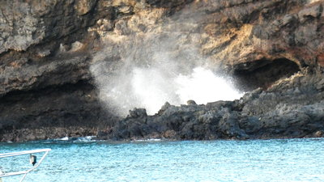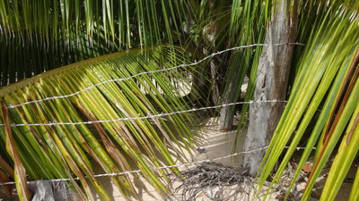
Blowhole on the north coast respect privacy

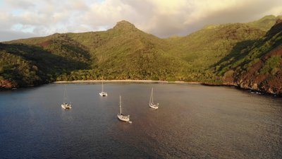
Hanamoenoa (Foto by Hamish Brewer, SV Dreamer)

Ivaiva Nui
Additon to 5.4, but I recommend spitting the two bays into seperate chapters, so better:
NEW 5.4a Ivaiva Nui

SY TAITONGA, 08.07.2019
We made a day-stop here with 3 other boats carrying ca. 25 people from Hapatoni for a fun-day-picknick. A hut and structure ashore => it is a private bay! Nice, but not ideal.
Navigation lights: None, no lights ashore
Holding: Good at our spot in sand in 8.5m at position: 09* 54.49`S; 139*06.31'
There are rocks in the bay further to shore.
Swell/Rolly: It looked much more exposed and more swelly compared with Ivaiva Iti; some boatmovements, despite it was a calm day.
Water visibility: ca. 10m+ in clear water (we saw our anchor from the dinghy and rocks.
Dinghy landing: Should be done with great caution ! in the middle of the bay. There are very uggly stones in the water near the surfzone a bit north of the middle and on the beach there is a band of light grey, nearly invisible, sharp rocks, parallel to the shoreline, which could damage your dinghy or hurt badly your toe (for me: Ouch-Ouch-Bay!).
Beach: lovely, sand with hidden stones (see above), please respect the privacy of the owner. Only very few Nonos and mosquitos.

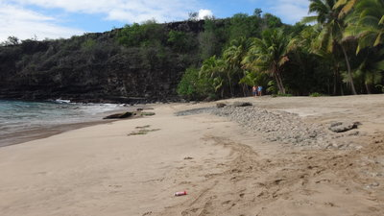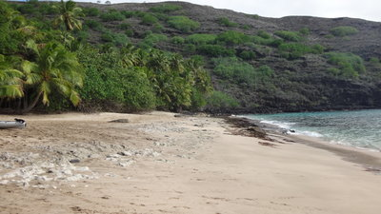
looking north looking south

Doing a picnic with locals - That's how it worked best for us:
a) it is great fun!
b) easy guests!
c) Our experience is everyone here can swim, exept maybe toddlers ...
d) If you do not speak french - doesn't matter! :-)

- Designate a VHF channel for the fleet, e.g. 68 international for communication
- Before entering the dinghy everyone should place their shoes into your bucket in the dinghy - this is easier for getting all the flipflops on the beach anyway.
- Big dinghys are best to ferry the people - they are not used to little wobbely inflatables, so they need to know where to sit.
- The leading boat should have the person on board knowing which beach is to be aimed for (If anchoring and/or landing looks unsafe there, take another beach!).
- The group of boats might stay together for giving them the opportunity to make fotos :-) (and maybe get some help in case of emergency from another boat)
- Have an eye on little kids and the local person at the helm :-)
- It looks quite picturesque, if you get e.g. the mainsail up, depending on the wind and gusts.
- Landing (and leaving) - Most important: If there is swell on the beach the strongest local should jump into the water first and his only designated job is to catch the dinghy and hold the bow in place towards the beach, outside the breakers, while the skipper is going slowly astern, so the dinghy never ever gets parallel to the swell! and the propellor is not even near someone! This has to be communicated to everyone before landing!
- Unloading equipment is done by doing a chain of people.
- Getting the dingy ashore is done by a dozen people extremely fast or if you have a big tender maybe anchor it in front of the beach and do a swim - Everybody gets wet anyway.
- Watch the boat and the weather from the beach (as usual:-).

Have fun !!!

Nuku-Hiva

South Coast

Taiohae (aka Rolly Bay)
Addition to 8.1.1

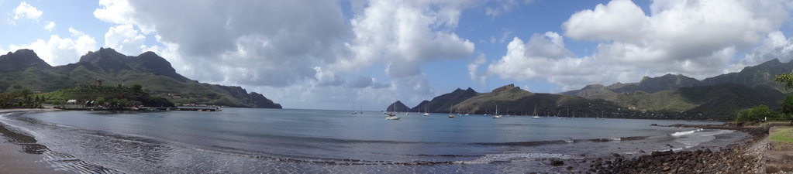
SY TAITONGA, 30.12.2018 (we stayed ca.3 weeks and returned in July 2019 for one week)
Nuku-Hiva – Taiohae (aka Rolly Bay)
60 boats in the U-shaped anchorage and still plenty of room. Rolly. Nice scenery but not as spectacular as elsewhere. Good supplies and some services in town.
Little harbour in the NE-Corner; the Cargo/Cruiseships do park at a massive concrete-dock on the North side of the bay.
Cruiseships might anchor in the bay and ferry passengers ashore.
We watched some Manta Rays (I snorkled with them), and I was watched cleaning the hull by an hammerhead.
No-Anchoring-Zone in the northern part of the bay (Cruiseshipdock+300m to shore) is a: 140*05,91W/008*54,74S to 140*05,89W/008*55,31S to 140*05,74W/008*55,33S (stated in order 1084/CM from 04.08.2016, you can get penalties).
Nice Pae-Pae in walking distance (uphill!)
Navigation lights: Navigationlights were working. The town has a lot of streetlights as well. (I would dare to anchor in this bay at night!)
Holding: At our spot: Good holding in grey mud with coralsand for the Bügel-mainanchor in 17m with 70m chain at 08*55,070S; 140*05,595W). Nearer ashore it is less deep, but maybe a bit more reflecting swell.
There is some current in the bay and the boats sometimes are stern to stern.
We returned 12.July (ca. 30-35 other boats) and anchored at pos 08*55'029S, 140*05'995W in 14m with 65m chain, The two first attempts failed while testing under full load (one seemed ok for a minute and than failed, imho the anchorground is a bit tricky and it could prove wise to test the anchor long and hard.
It is tricky to judge the distances, because (like in December) the boats are "normally" lying chaotic to each other and the quick changing gusts from various directions combined with the tidal current does not make it easier => calculate a good distance (it is a huge bay without the need to have a neighbour in a boat-length distance).
We moved on to the W corner one day and had a sternanchor out in 8m => it made a difference.
Water-visibility: ca. 4-5m in dark water, (after heavy rain 20cm).
Fouling: After 3 weeks our alu-bottom (with nearly no antifouling left) was very badly covered with weeds, sponges and barnacles (like a living 3cm thick carpet) but relatively easy to scrape; it took ca. 60+ minutes to clean the weedy anchor chain
In July 2019 we had weeds after 5 days on a fairly new antifouling,
Wind and weather: The weather forecast (outside) was at the beginning ENE-E 17-21kn, gusts 30, sea moderate E 1,5m.
What we got: All directions, only a few gusts, often NW 10-15kn.
(The breaking waves at the bay-entrance (Sentinelle de l'Ouest) can be used as an seacondition indicator)
Swell/Rolly: Quite some boatmovements (3 to 4 out of 5 on the Dagmar-Scale). The tide often pushed us to 90 deg to the swell. When a bigger southerly-swell is coming in, I do not want to be here!!! (Some cruisers reported that sometimes it is not possible to go ashore)
Mid July we had swells around 1-2m, the peak lasted a couple of days, the waves were breaking quite high at the beach, creating a reflecting swell, that was steeper than the incoming swell - even cats rocked (a bit),
Local traffic: ocassionally fishers and supplyships aswell cruiseships (then it get's busy with their tenders)!
Dinghy landing: There is not a designated "dinghydock" for cruisers. L-shaped harbour for little crafts in the NE corner. In front as well behind the breakwater, they have med-style moorings with stern-buoys for the local motorboats. When you go in, better do not cut corners and look out for lines between the buoys and dock. Some mooring-buoys are placed outside the harbour as well (You can offer a ride to the drivers, because they usually do not want to swim, because of the sharks => fish-cleaning-area (little kids use the ramp etc. as a swimming-playground).
There are two ladders (ca. 1-2m) up the concrete dock lefthandside of the steep ramp in the corner. The locals share these ladders and the space with us as a courtesy! The ladder closer to the ramp is harder to climb (a handle on top is missing) and normally has fewer dinghys. There are horizontal ropes to tie the dinghy to, so the ladder stays clear from the dinghyropes !!!, if the painter is to short your dinghy might be pulled upon another one by the tides. It can be very cramped and local boats aswell big dinghys moored here can do some damage. It can be a good idea to buddyboat to minimize the traffice. Some dinghys carry lines of fenders as a protection against the sharp shells on the wall (was nicely cleaned in 07/2019).Around the corner towards the beach is another option to tie up your dinghy at a concrete wall on the N-side going towards the beach (not so crowded), closer to the beach is better (stern-anchor maybe usefull). There are two lower sections in the concrete to climb out. Do not use the first 15 m from the corner (with the first climb-out), because these are used by the locals to board their vessels with passengers and the cruiseshiptenders (as well here are the fish-cleaning-tables and the walls are more covered with sharp shells :-).
Some dinghys land on the beach directly.
Mid July 2019 we had larger long swell (1-2m) coming into the bay - the dinghys were nearly thrown ashore at the ladders at high tide (around full moon)! The landing around the corner towards the beach turned into a surf zone, one massive dinghy capsized. At least 4 dinghys got damaged. If a line of the bigger motorboats comes under a dinghy and the line straightens out through the swell, the dinghy can be catapulted and land upside-down.
Beach: Sand (near the dock), rocky sections in the middle of the bay
Trash-Disposal: Please help to recycle: here they separate the trash and treat it as a ressource for recycling => containers are ca. 50m from the Touristinfo towards the carpark: aluminium, cans, glas, opaque plastic, clear plastic, batteries (only 30m detour from going into town). Additional big containers in a housing at the exit of the harbour for the normal rest trash.
Water: Water (not potable) is available at the dock with several hoses!
FILTERED water is available at two stations in town for free. (Do not do your laundry there:-)
Check-In: At the Gendarmerie, weekdays between 07:30 and 10:00 (easy process)
Gendarmerie: 40 920 305 (location going towards the east, see the map)
Tourist office: near the dock, ask Colette (She sells fresh produce as well); 8:00-12:00, www.nukuhiva.org, comitedutourisme.nukuhiva@gmail.com, 40 920 -825 or -285 (see map)
Flying objects: Ashore: Mosquitos and Nonos; on the boat: 4 Mosquito. In July 2019 they had 2 dengue patients in hospital on the Island, and 40+ in Tahiti => protect yourself.
VHF-Net: Channel 72, 08:00 [for and from cruisers: If you do not hear a netcontroller, you are very welcome to do the net yourself!] (most cruisers use 72 as a hailing-channel)
Internet: Wi-Fi at the dock-restaurant Snack Vaeaki (support them for that by buying drinks or food!) - the password is displayed on the ordering-table; as well Nuku-Hiva-Yacht-Services and several places in town, e.g. the library (yearly membership 1000XPF, closed during holidays, but mostly they leave the Wifi on)
Vini-cell-coverage - Internet worked on the boat for emails (in the morning:-) [it was possible to receive and send emails 8nm out of Taiohae!].
Vinispot for WiFi in the bay available to log in.
SSB: sometimes ok(ish) for checking into the Polynesian-Magellan-Net
Iridium-Access: good, despite the mountains
Money: Bank with ATM (max 100000 XPF (never saw a bigger max!)),
Post (mon to fri: 07:30-11:30,12:30-15:30 (fri14:30)) with outside-ATM (not working, 01.2018)
Church service: Cathedral Notre Dame des Iles Marquises: sun 08:00+17:00, sat 06:00, weekdays 17:30; Mormon Chapel and Jehovas
Services:
- Nuku-Hiva-Yacht-Services - Wi-Fi, laundry, care-taking of anchored boats, rental-cars, check-in, duty-free-fuel-formalities, sail-repair, shipping stuff which can not be done here to Tahiti, sells icecream !, etc.; Kevin 87 226 872 (english), Annabella 87 794 830 (makes nice fabrics!), VHF 72; mon-fri 08:30-11:00, 12:30-15:30, tel 40 920 750, www.YachtServicesNukuHiva.com, ysnukuhiva@hotmail.com, nice and helpful service!
- Canvas work and tender construction, Pierre, SY Tivano lives in a house on the hills, tel. 87 32 47 29 (also bookable through NHYS)
- Cineclub (in french) - see blackboard at the library
- Pharmacy: see Info-Map
- Hospital: see Info-Map
- Dentist: Mr. Pierre Puech, Chirugien-Dentiste, 40 920 418, 07:30-11:30, speaks a bit english, has a diploma from Toulouse and is the only private dentist in the Marquesas (public dentists only in Ua Pou and Hiva-Oa). Some mixed reviews from cruisers, my own experience was good (check only) => check it out, as allways:-). Go towards Magasin Celine and take the road to the right after crossing the bridge, follow the main road besides the stream, take the road to the right after crossing the next bridge, walk straight and after having reached the "bus-stop" take the next turn left after ca. 100m into a dirtroad - second house (two stories, green-turquise) on the right on the ground floor (took us (slow) ca. 40 min.). The waiting room is outside (mosquitos!). Pos.: 08*54'21.58''S; 140*06'23.70''WVet: Ludovic 87 343 136, in the same road as the dentist, only further
Transport:
- see Taxis-No on the Info-Map
- Air Tahiti office mon-fri 08:00-12:00, mon-wed-fri 13:30-16:30, tel.4091 0225, Marie-Helene; you can do a reservation via a central hotline as well (and pay later online or in an office): 40 864 242 (press 2 for english!),www.airtahiti.pf
Laundry: Nuku-Hiva-Yacht-Services: 1500XPF wash, dry, fold a load, (imho good quality)
Kapa: 600xpf (wash) to 1000xpf (wdf) (can collect and deliver for 300xpf, you can leave it with Celestine at the market) tel. 87 349 189, mon-fri 07:30-16:00, sat 07:00-12:00
Bottom-Cleaning: Pierre (SY Tivano) lives in Nuku-Hiva , 35USD/h (calculate 3h), tel. 87 324 729, as well bookable via Nuku-Hiva-Yacht-Service, Pierre is manufacturing glasfiber dinghys as well.
Diving: Between Nuku-Hiva-Yacht-Services and the Boutique (Ask in the boutique)
Restaurants:
- Snack Vaeaki - they have Wi-Fi! 7 days a week from 06:30 to 15:00, main courses around 1000XPF, tel. 40 920 551
- In the market
- Moana Nui, wood fired pizzas, tel. 40 920 330
- see Info-Map
Grocery/Shopping:
Fresh-Produce-Market with ca. 10 tables next to the harbour, mon-fri: 06:30 to 15:00, sat: 04:00 to 10:00; Wed and Sat seem to be the best days
Fresh-fish direct from the fishermen (they do not talk a lot) at the harbour between ca. 05:30 to 06:30, kg/500xpf in 2019, you might have to buy the whole fish or half (share-options on the VHF-net:-)
Magasins (they do have a bit of everything - very limited selection after 4 weeks without supplyship) (from W to E)
- Hoata, mon-sat 06:30 - 19:00; sun 06:30-12:00, 14-19:00; Owner is Marie-Louise, far to the west past the pharmacy, call for pick-up and/or drop-off (suggested spending in the store for this service 5000xpf); tel 40 920 021
- Celine, mon-sat 06:00-12:30, 14:00-18:30, sun 09:00-12:30, 16:30-19:00, tel. 40 920 160
- Larson, organic and specialities, and some fishing equipment, mon-sat 07:30-18:30, sun 07:00-12:00, tel. 40 920 331
- Kamake, they bake their own bread (good!) as well cookies, mon-sat 05:30-11:30, 14:00-18:30, sun (no bread) 05:30-11:00; tel. 40 920 322 (Bread might be sold out after 09:00, but sometimes they do a new batch for the afternoon; you can prepay for tomorrow and collect the reserved bread at your desired time)
The bread is carried mostly in plasticbags - for the crispyness it is much better to carry it in a self-made cotton sack (more ecofriendly as well:-)
- Putoka, tel 40 920 332
Hardwarestore: Bigot, tel.4092 0434, carries building-supplies, a bit boat- and fishingstuff, Makita-tools, few Yamaha-parts, gas-bottle-adapters for gravity-fill , some stainless items and a bit of everything as well has a clothing, shoe and toy section (No store in Taiohae carried manual fly-flaps (only electric ones). Turn right before Larson and walk uphill ca. 500m until the busstation/recyclingcollection, turn left and proceed for ca. 80m (best to hitchhike uphill:-).
Little stores/workshops with hardware on the road to the cruise-terminal (dito most magasins carry a bit).
Patisserie: order only - Les delices de Josiane, tel 920 874, e.g. Tarte a la banane (6/7 persones) 3800xpf, Royal chocolate au 3 chocolates (8-10 persones) 6000xpf
Barter: -
Diesel/Gasoline: At the Total fuel station at the cruise-dock; tel. 40 920 618 mon-sat 07:00-12:00, mon-fri 14-17:00. Very nice service! They carry diesel- and outboard-oil. They accept the duty-free-certificate for diesel (you can get one via Yachtservices-NH or other agents or for free in Papeete (in person). You can park the dinghy at a ladder (NW-Corner of the dock), go up straight ca. 3-4m (on top is a handle to make it easier). I lowered my jerry cans down into the dinghy with a rope. With some swell I would not do it. The dinghy might get trapped under the dock at lowtide.
We have seen very big yachts go alongside the dock or motoryachts going between a poller and the dock, but maybe check the size of the nozzle of the fillinghose first, if it fits into your boat.
Cooking-gas: Exchange bottles at the fuel station or ask the supermarkets, (13kg refill 2899xpf, deposit 3000xpf in 2019) or use Nuku-Hiva-Yacht-Services. Hose-adapter for the local gasbottles for DIY gravity-fill was available at the hardwarestore Bigot in 07/2019 for ca. 1100xpf (fits a 8-10mm hose, I had to work on it to fit 6mm and drilled out the security-ball inside).
B+B/Pension/Hotel:
- see info-map
- Pension Moana Nui with restaurant, pensionmoananui@mail.pf, +689 920 330 :e.g. double with breakfast: 9900xpf/n + tax (2019)
Rental Cars: Pension Moana Nui: e.g. Suzuki Jimny 4x4 for 10000xpf/d (2019)
Welding/Metal- and Woodwork: Workshops on the road to the cruiseship-terminal
Dance Class: Some cruisers attend the local dance classes and swing their hips and meet locals!
Events: New Years Eve, National Day etc. they host partys at the hall 100m from the touristoccice towards town. It can be a good idea to reserve seats at a table in advance. Walk-ins get a seat in the last row ("Poisson Crue au lait Cocco" on bastille day was outstanding good !!!).

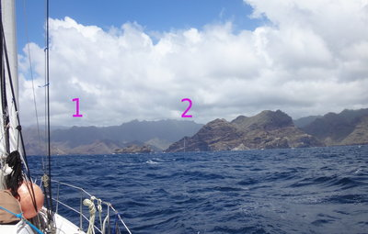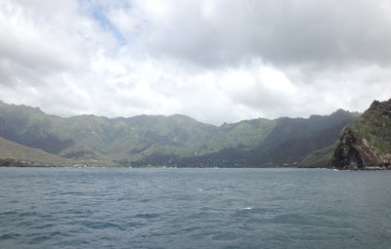
1 Entrance to the bay (west of the little island) Bay of Taiohae
2 Vertical white line in the rock as an indicator

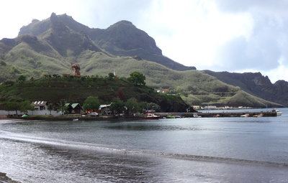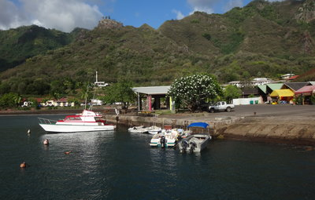
L-shaped harbour + additional wall to the beach Ladder 1 where the dinghys are
In the background the cruise-ship-terminal Ladder 2 betweeen the motorboats
(near the ramp in the corner)

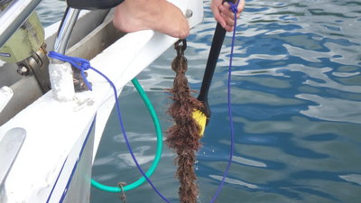
Fouled chain after 3 weeks in January

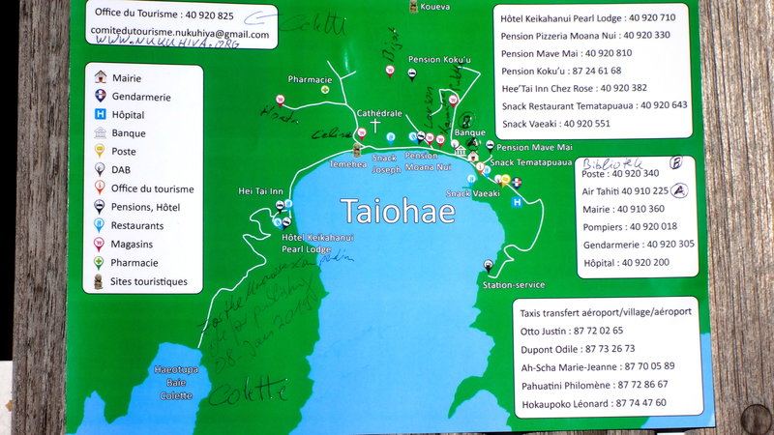
Info-Map from the Tourist-information-office (Colette allowed it to be published in the M-Compendium)

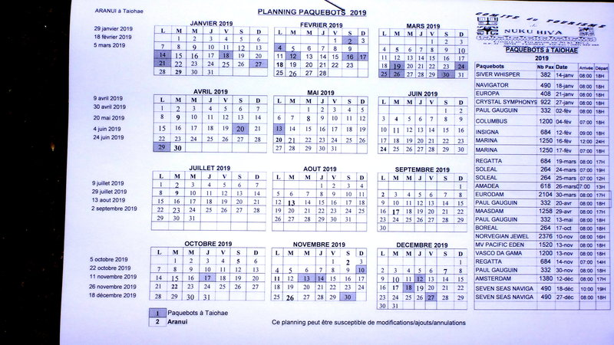
Schedule 2019 for Cruiseships and Aranui in Nuku-Hiva, Taiohae
(the actual date of the Aranui arrival can differ a bit)

Walk description to Koueva (ancient site) (ca. 45 minutes uphill one way)

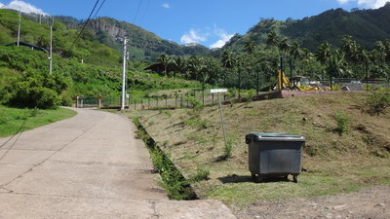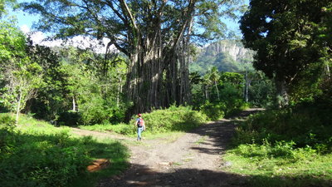
Follow the Road from Magazin Larson up the hill At the Banyan tree turn left
"Koueva" - Signpost (left of the garbage container
[not always there:-)] => turn right

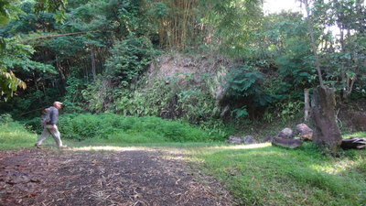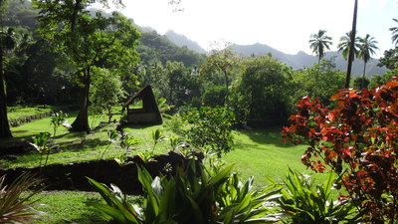
next turn right Koueva - you will find some Tikis in lush green

Daniel´s Bay (Hakatea) (aka The Wall Bay)
addition to 8.1.3
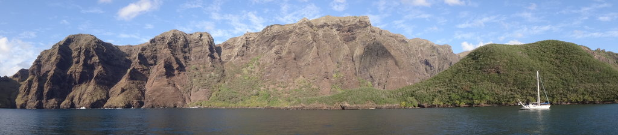
SY TAITONGA, 30.12.2018 (we stayed ca.3 weeks )
Nice scenery, a high mountainwall on the west side, beautiful, peaceful and birds are singing.
We shared the east-anchorage with 4 other boats and 2 mooring-buoys which are close to shore and are used by the residents of the lonely house above the beach (we had a nice contact with the lady).
Navigation lights: -
Holding: At our spot: Good holding in mud for the Bügel-mainanchor in 7m with 35m chain at 08*56,657'S / 140*09,826'W. Nearer ashore it is less deep, but maybe a bit more Nonos?
There is some current in the bay and the boats sometimes were stern to stern.
Water-visibility: ca. 2m in dark green water.
Wind and weather: The weather forecast (outside) was . east 11/16KT locally 17/21KT, gusts 25/30KT, sea moderate, 1,5 meter to 2 meters.
What we got: All directions, mostly ENE and SW (alternating in seconds), a few gusts in the upper 20ties.
We returned in August 2019. Weatherforecast (12h old) from Meteo.pf: sun predominates from thursday and friday with of clouds SE developing on the relief at/in the mid-day. Wind from sector east moderated, tips at 50 km/hr...; GFS-Gribfile: 17-20kn, gusts 25kn, cloudcover 5-15%;
What we got: Wind from all directions, normally low, but gusts 30-40kn (mostly from N-NW) and a lot of rain. The rain looking towards the mountain was going into 2 directions at the same time: W and E; boats 100m away got different wind-conditions; Outside a friends boat reported squalls 40+kn. The 2+m waves outside came in as "little" swell (very enoying) around the corner towards the beach (still better than the swell in Taiohae, but far from great). The swell either hammered into our stern or made us do the metronome. The conditions improved the next days, the wind/gusts came even from SW and NW, still a lot of rain.
Swell/Rolly: Some boatmovements (2-3 out of 5 on the Dagmar-Scale), the swell is reflected by the mountain.
Local traffic: Small motorboats (3max) bring day-tourists and visitors from Taiohae
Dinghy landing: Left side of the beach (at LW submerged stones at the very far left; in the middle of the beach are stones at LW) with acces to a footpath to Hakaui. If you approach the beach you will pass an outstanding tree ca. 20m from shore - that is where the trail starts, going west around the peninsula (slippery when wet), nice walk ca. 20 minutes to the first house with a little river-crossing. Good shoes might be useful. If you go to the hamlet be prepared to cross a stream; water can be up to the hip. It was reported that it is possible at hightide to take your dinghy into the stream (you might have to drag the dinghy a bit over the sandbank).
Beach: White sand
Flying objects: Ashore: Some mosquitos and nonos; on the boat: many, many flies.
Wildlife: Birds are singing, sometimes manta-rays are visiting.
Trash-Disposal: -
Services: Kua (speaks english) +Taiki in the hamlet can sell you fresh produce and can serve you a meal (1000xpf p.p.)
VHF-Net: Channel 72, 08:00 from Taiohae - the signal is not great but works
Cell-phone reception: -
Internet: -

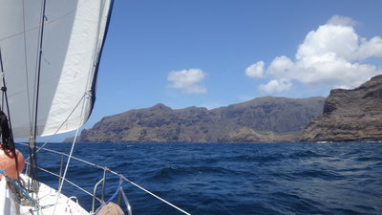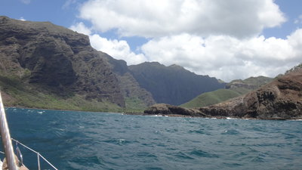
Approach Breakers at the entrance despite only 1m swell!

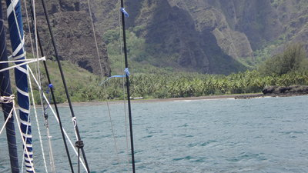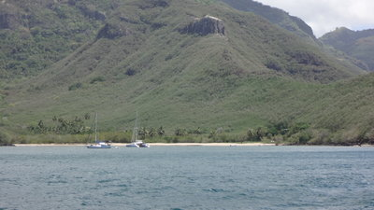
The north beach Daniels Bay
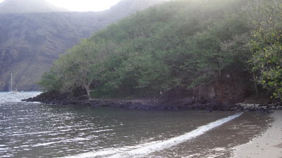
Path to the hamlet (towards the tree)

North Coast

Anaho (aka Birdsong Bay, aka Squally Bay)
Addition to 9.3.1 Anaho

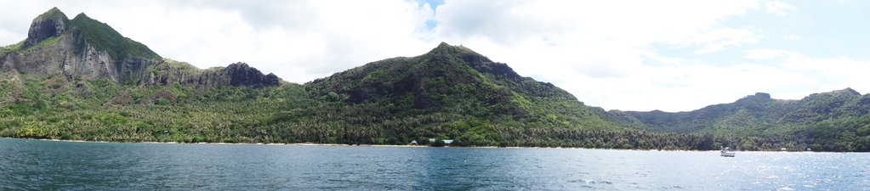
looking SW
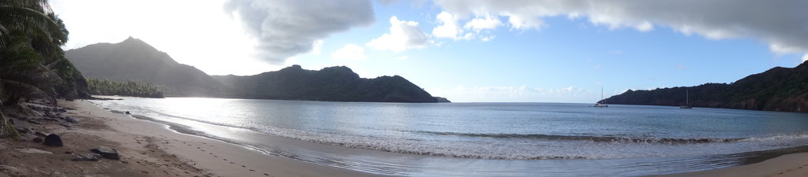
looking N

SY TAITONGA, 22.07.2019 (we stayed ca.10 days)
We went from Taiohae east to Anaho, to escape the southerly swell, during our trip we had 5-10kn NE, 1,5m confused waves, due to reflecting windwaves from the coast and the southerly swell. Funny currents at the capes.
0,3nm south of the south-east-corner of Nukuhiva we stayed clear of the small rock "Teohootekea" which seems to be only 1-2m high and not very visible in bad weather.
Nice scenery and we enjoyed birds singing since a long time. (Everyone recommended Anaho to us as "the best bay" of the Marquesas - it is a nice bay, and we liked other places even better :-), very nice inhabitants!) The highest mountain is named Kaniho.
5-8 other boats in the bay as well as some swell, despite the little mountainspit north going east keeps a lot away.
Navigation lights: -
Holding: Good holding at our spot in sand in 11m with 55m chain at pos.: 08*49'41S, 140*03'82W.
The local "Association Tukemata O Kaniho" recommends anchoring in 11+m to stay away from the coral. There is an anchoring restriction from a prolonged line of the channel to the north (see foto)
Boats were asked by the locals to reanchor, when they blocked the small boat channel.
Some boats anchored at the east side of Anaho - less fetch and different wind.
We had every second or third night squalls with rain and onshore gusts up to ca. 30+kn (mostly before sunrise). During a day with 15-20kn, gusts up to 30, a friends boat was anchored in Hatiheu and experienced 6-8 kn with no gusts.
On our return from Hatiheu we anchored in 16m with 62m chain at pos.: 08*49'309S, 140*03'807W. The first attempt did not grip and it is deeper here, compared to 50-100m south, so the swingcircle can be different to other boats as well the winds are different to our first spot. Depending on the wind we were unfortunately lining up directly with the channel.
Swell/Rolly: boatmovements 2-3 out of 5 on the Dagmar-Scale; the 1/2nm fetch makes it with more wind a bit uncomfortable, dito if there is a northerly wind-component involved and some swell comes into the bay. The anchorage in the east seems better protected against wind, but more open to swell.
Dinghylanding: Buoyed channel, besides the channel many rocks up to the surface, some buoys are interconnected with ropes and do not line up 100% towards the beach. (I would avoid a moonless night:-)
Local traffic: Sometimes a local alu-motorboat
Water visibility: Ca. 2-7m, depending on the rain
Fouling: Not much
Beach: Sand with some rocks and a big reef in front; sandy beach in the east without reef, but some rocks. There will be no beach at HW (after new moon).
Restaurant: "Kaniho" is run by Teiki (a bit english) and his wife, his brother runs the pension behind the restaurant. Teiki has a little farm as well and sells fresh produce (great Mandarines), if the restaurant does not need it. Open: 06-09:00; 11-14:00; 17-20:00, Reserve a table 8-12h in advance under tel. 40920716. Nice food and service, no WiFi. Mains around 1500xpf.
Trash-Disposal: None ashore. Please take care while getting rid of organic foodscraps - despite an outgoing tide they might land on the beach, because of the onshore-wind.
Wildlife: Birds were nicely audible! 2 Baby-sharks near the beach.
Flying objects on the boat: only a very few, but some flys and 2 mosquitos and we brought a couple of nono's onto the boat.
Cellphonereception: Yes. Data-reception was not possible for us, but whatsapp came through.
WiFi-Internet: None
Iridium-Access: ok(ish), despite the mountains
SSB: Good enough (mostly) for checking into the Polynesian-Magellan-Net
Walking: Hatiheu: there is a path to Hatiheu, going left from the landing, passing the chappel, after ca. 300m turn right into a very small path (which lookks like a dryed out little stream), after a concreate foundation at pos. 08*49'117S, 40*03'473W. At the highest point (217m) you will find an white antenna tower (visible from the bay) with a very nice view to the Bay of Anaho (going down no view onto the bay of Hatiheu). The path is mostly in the woods (some mangotrees on the way), steep and rocky (I would not do it after rain!!!), the last bit in Hatiheu is a steep concrete road (not good for kneeproblems). A local guy said 35 minutes walk - it took us ca. 90 minutes, one-way. Water, walkingsticks and mosquito-repellent is a good idea.
Fruit and Vegetable: Farm Moana - big farm towards Bay Haatoatoa; Pos. ca. 08*49'49S, 40*03'04W: Walk towards the last bay in the east and walk further towards the east (there is only one path). It took ca. 50 minutes one way (if you take the dinghy to the beach furthest to the east you will cut off ca. 30 minutes). Nice, moderate walk in mixed sun and shadow. Best chance to meet the owner is in the morning! Tuesday and Friday afternoon (maybe for the whole weekend?) they go to Taiohae (dito the day before the Aranui arrives) to sell their produce, e.g. tomatoes, eggplant, cucumber, breadfruit, pampelmouse, melon, lemon, passionfruit, bananas, pumpkin, etc. Contact (no cell-signal on the farm): Moana and his wife Marie (a bit english): 8777 3313; Doly, her daughter, in Taiohae 8771 3334.
Farm Teiki (owner of the restaurant): Walk towards the restaurant on the beach and ask for directions and what they have, e.g. Mandarines, lettuce, pak choi; ca. 5 min uphill, much smaller than Farm Moana, in business since 2019.
Ciguatera: the "Direction de la sante" issued an Alert for Anaho and Hatiheu.
VHF: Communication to a boat in Hatiheu was possible, but sometimes scratchy.

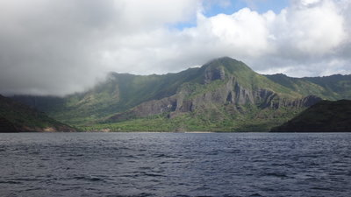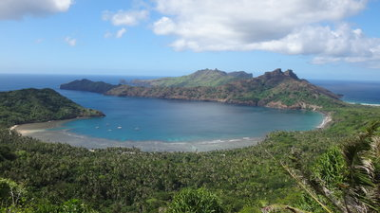
Approach Bay of Anaho

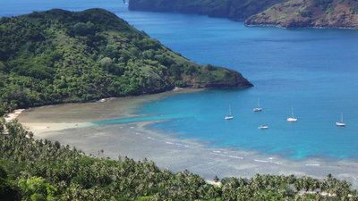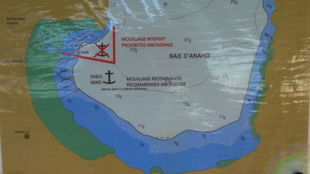
The dinghy-channel Anchoring restrictions (from the local blackboard)

Hatiheu
Addition to 9.3.2 Hatiheu
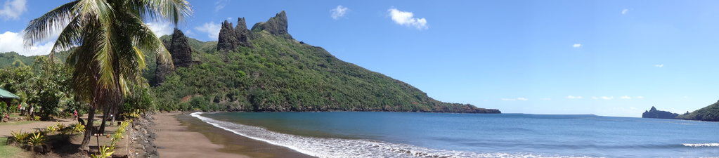

SY TAITONGA, 31.07.2019 (we stayed only a couple of hours)
The promenade at the waterfront is manicured with beautiful plants and some tikis.
Holding: ok-holding in sand with gravel or rocks ? in 10m with 50m chain at pos. It took us 3 attemps until the anchor-test was good. Us and only 1 cat in the bay.
Swell/Rolly: boatmovements 3-4 out of 5 on the Dagmar-Scale; we had less than 1m swell onshore, during 15kn ENE wind outside on a very squally day. Could be maybe much calmer with a southerly component, it looked calm from ashore during our first visit on foot. (The people on the cat were happy; we motored back to Anaho for the night)
Dinghylanding: We took the dinghy onto the beach beside the westerly ramp (with sweetwaterfaucet) and hurried to run our errands. The beach seems to disappear at HW. Anchoring in front of the surfline could be a good possibility or taking the dock in the east.
Cellphonereception: Yes, but no data (whatsapp worked)
WiFi-Internet: Vinispot, but not possible to pay online for us
Post OPT: Open Monday, Wednesday, Friday; 07-10:00 (during schoolholidays) (non-schoolholidays in the afternoon; if there are not many customers they might close early)
Restaurant: "Chez Yvonne", big restaurant.
Shopping: Yvonne runs the shop besides the restaurant, 07:30-17:00, but closes down if the restaurant is too busy, which was the case on our visit. We did not visit the other magasin.
Sites: Big ceremonial grounds near the hamlet. Take the concrete road from the postoffice walking uphill ca. 20 min, left side is the first site; walking another 15 min uphill there is a very big compound left and right of the street. Surprisingly only few mosquitos around, but all of them waited for us at the french explanation-boards, surprisingly they bit me through my t-shirt.
We had the sites for ourselfs and were passed by maybe every 4x4 car of the island going to Hatiheu that day, all packed with pale tourists (the Aranui arrived in Taiohae!), having lunch and a danceshow at "Chez Yvonne" (booked out) and maybe afterwards visiting the sites.
I would have enjoyed a guided tour here and would (next time?) ask around if anybody could be hired for that.

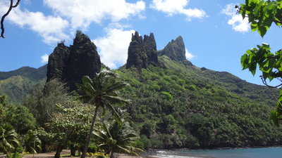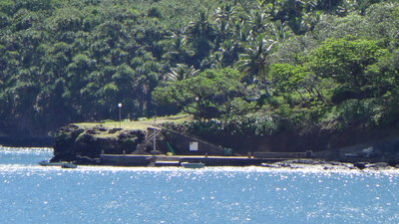
the rocks to the west dock on the east side

Archeological Sites Tahakia-Kamuihei-Teiipoka
Walking distance from Hatiheu
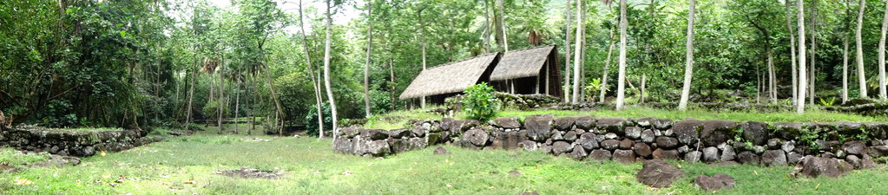

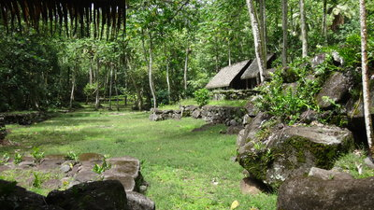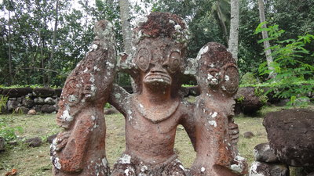
Visitors from where?
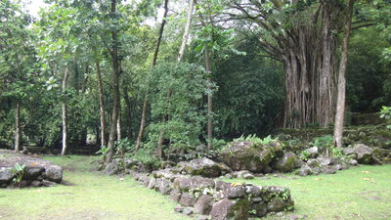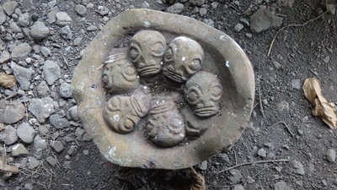
Quick-Business-Lunch?

Hakaheu/Pua
Addition to 9.3.3 Hakaheu/Pua
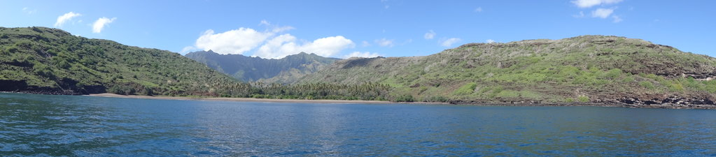
SY TAITONGA, 03.08.2019 (we stayed only 20 min:-)
Nice Bay, some swell still came in, but would have been ok(-ish). We would have anchored in 6-8m in the east corner, which looked like sand on the fishfinder, but decided to move on further south.
On the eastside of the sandy beach is a little stream, on the west a bigger stream.
It looks like a working coconutfarm, some houses and huts ashore.
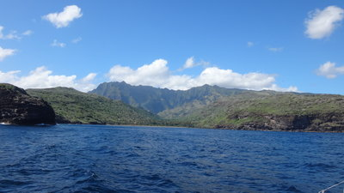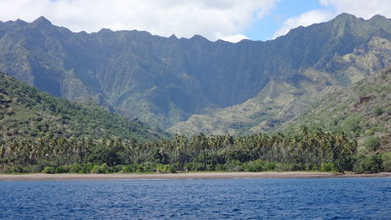
Approach Beach

Bay Moutee
Addition to 9.3.4 Bay Moutee 08 47.5S 140 11.6W

SY TAITONGA, 03.08.2019 (we only had a look from the distance)
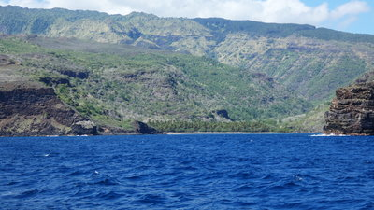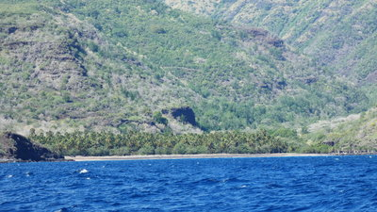
Approach Beach

West Coast

Baie Marquisienne (Anse Uea) (aka Sound of Beachpebbles-bay)
Addition to 9.2.1. Marquisienne (Anse Eua)
[in OpenCPN it is named Baie Marquisienne (Anse Uea), dito in Navionics]

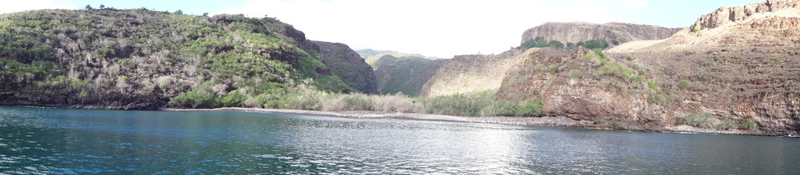
SY TAITONGA, 03.08.2019 (we stayed 2 nights)
Nice little bay at the end of a dramatic steep valley, covered with clouds ontop.
Holding: Good holding at our spot. We anchored in ca. 5m with 30m chain at pos.: 08*54'914S; 140*13'397W on sand, while snorkeling the anchor I had to find out that about 15m to the east were some rocks. The sandbottom expands until near the shore.
We reanchored: Good holding at our spot. We anchored in ca. 8m in sand with 40m chain at pos.: 08*54'884S; 140*13'394W.
Swell/Rolly: 2-4 out of 5 on the Dagmar-Scale, Surprisingly good sheltered (in the first night). Only little swell coming towards the beach, BUT most of the time the swell came 90* to the boat.
The second night was quite uncomfortable, swell from NW with ca. only 30-50cm, but the frequency was really shaking us. Without the swell this would have been a fantastic bay.
Wind and weather: The weather forecast (outside) - Grib: 15kn E; Meteo France E 17/21kn, gusts 25kn.
What we got: Wind mostly from SE to SW, sometimes NE, sometimes W, around 10kn; some little quick gusts. I waited for uggly, vicious gusts coming either down or up the valley, but we only got little wind from that direction, despite the clouds above going towards us (lower clouds with a southerly component, higher clouds with a northerly component). A boat outside reported 18kn. Second night mostly 10-15kn down the valley or ENE.
Watervisibility: 5-8m
Beach: Steep with gravel/rocks (making a nice sound in the little surf) and dense vegetation in the valley.
Wildlife: Only a few birds are singing sometimes, goats are making funny noises. Some nonos and many flies on the boat.
Internet: No cellphone reception
Sunset: Nice over the open sea
Going towards Taiohae we had all the time wind, which followed the coastline, which means directly on the nose, confused seas at the Cape, windspeed according to the weatherforecast 16kn, with gusts 20+kn, seas 1,5-2m.

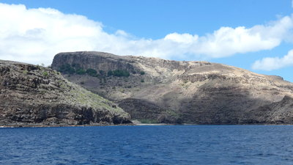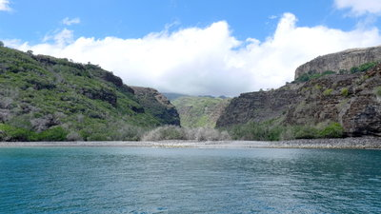
approach from the north pebble-beach

Haahopu (Airportbay)
Addition to 9.2.2. Haahopu
SY TAITONGA, 03.08.2019 (we stayed only 20 min:-)
Going around the corner towards the south we had some strange waves and currents.
The wind followed us with 10-15kn for about 1nm and then died. We keept a good distance from the rocks NW of the entrance (visible in Navionics charts as well in CM93), they were barely visible around LW.
Good sheltered and only very little swell coming into the bay.
There is a big concrete dock in the north with steps and some local little fishingboats on mooringballs.
At the steep, sandy beach some local people were enjoying their weekend with tents and snorkeling the rocks for seafood. The surrounding looked a bit dead, not too much green, many little grey trees with no leaves. Imho the landscape is not as nice as in other places.
We would have anchored in 5-6m just in the middle (8-9m looked not too promising), which looked like sand on the fishfinder, but decided to move on further south and were surprised that a southerly wind came up as soon as we rounded the corner. We got 15-20kn, gusts 25kn directly on the nose, parallel to the coast and ontop the windvave we got a long (but low) southerly swell. (The weather forecast (outside) - Grib: 15kn E; Meteo France E 17/21kn, gusts 30kn.)
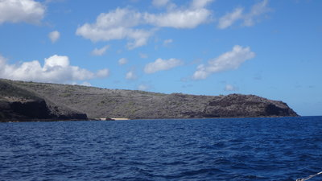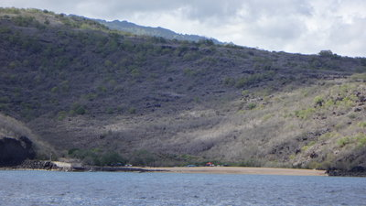
approach from the north beach
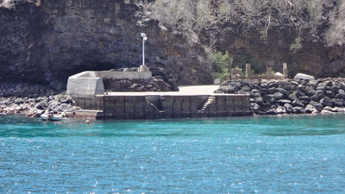
dock

Ua Pou

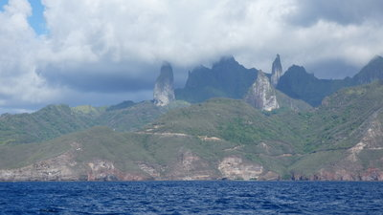

Hakahau
Addition to 8.1.1
SY TAITONGA, 15.08.2019 (we did not visit here)
We got the recommendation from another boat, who was very pleased with the dentist:
Dentist: Dr Guirado André, Chirugien-Dentiste, Centre Dentaire de Hakakau, D1168

Marquesas-Festival: The "little" festival will take place in December 2019 shortly before xmas, during schoolholidays => public transport could be busy (the big festival takes place every 4 years; in 2021 on Nuku Hiva). We know personally already about 12 boats who would like to attend. There might be not much space in Hahakau. Unoffical statements we got: Most boats will be asked to anchor in Hakahetau (which was reported to be very rolly beginning of August). Transport to Hakahau is t.b.d.
Between Taiohae on Nuku-Hiva and Hakahau there might be an shuttleservice by little motorboats. Some of the participants will sleep in schools or other public buildings (maybe bring a tent and use public showers and toilets?).
Telefoncontact CODIM for further infos: 4092 7307.
marquesasfestival.pf

Haakuti
SY TAITONGA, 25.08.2019 (we only had a look from the distance)
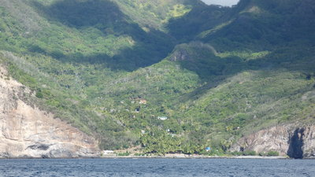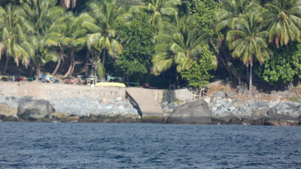

Vaiehu
Addition to 8.2.2
SY TAITONGA, 25.08.2019 (we only had a look from the distance)
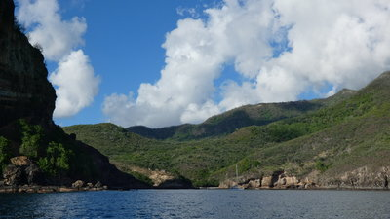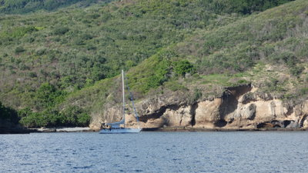
On the east side of the bay are some local buoys.

Hakaotu (aka calm. lonely, coloured rock bay)
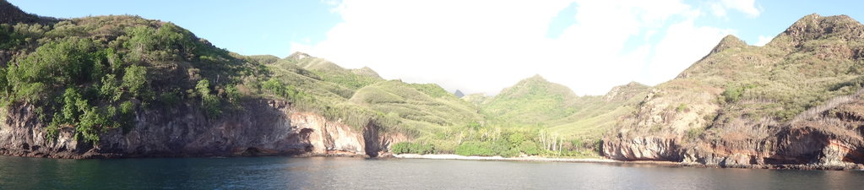
Addition to 8.2.3
SY TAITONGA, 25.08.2019 (we stayed a night and liked it)
Nice scenery with the standing rockpilar (natural obelisk) at the N-entrance as well colourfull rocks on each side! One big rockspire of the island is a bit visible, but covered with clouds.

Making the passage from NH to Ua Pou we had a brief look at Haakuti from far. The bays north of the peninsula with Cap Punahu had still wind and swell following the coast around the north side of the island. Conditions were much calmer on the S-side of the Cap, the S-swell was ok.
The buoy near Cap Punahu in our navionics as well OpenCPN-charts was not in place.

Holding: Good at our spot: 09*23'857 / 140*07'684 in 10m with 50m chain, slightly rising sea bottom towards the beach, sand.
Swell/Rolly: boatmovements 1-2 out of 5 on the Dagmar-Scale, very little swell coming in the good protected bay, very calm wind out of the valley, no gusts,
Local traffic: -
Water visibility: Ca. 8+m
Beach: big boulders, right side of the bay is obvious private property with a fence and a mooringboy very near the rocks.
Wildlife: Birds nesting in the trees, goats, a manta passed by
Flying objects on the boat: Some NoNos on the boat (maybe imported from Daniels Bay on NH)
Cellphonereception: No (but outside with data, going towards the Tuamotus)

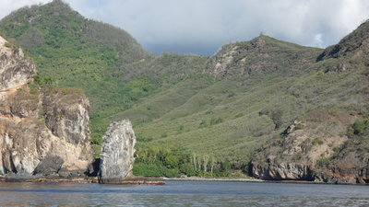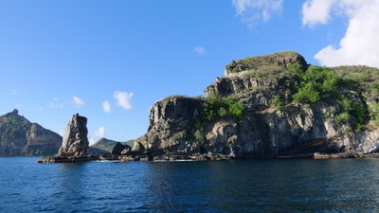
coming from the north looking north
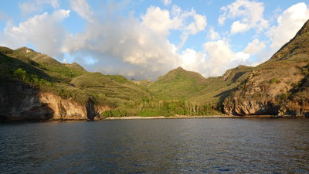
looking towards the beach

